Using iNaturalist
iNaturalist is a large international, geospatial data base for reporting the presence of a species at a location. It is a useful tool to map the distribution of a species from reports of citizen scientists. It is pretty easy to use and observations can be entered into the data base either from your computer by using a web based tool or from your iPhone or Android based smart phone with an app. iNatualist asks you to provide a number of data: the species you observed, the location where you observed it (latitude and longitude coordinates from your phones GPS or google earth), other observations at the local (for example vegetation type like forest, field, garden etc). From the data entered by all users it produces a map of where the species has been observed. The map is updated within a few hours of a report.
You can download the iNaturalist app at the App Store or Google Play. The app is free. Or if you prefer to use a computer, a web-based version is available and you can sign up and sign in at https://www.inaturalist.org/home
I will go through how to enter the data we collect at NBNC into the web-based program if we have internet access.
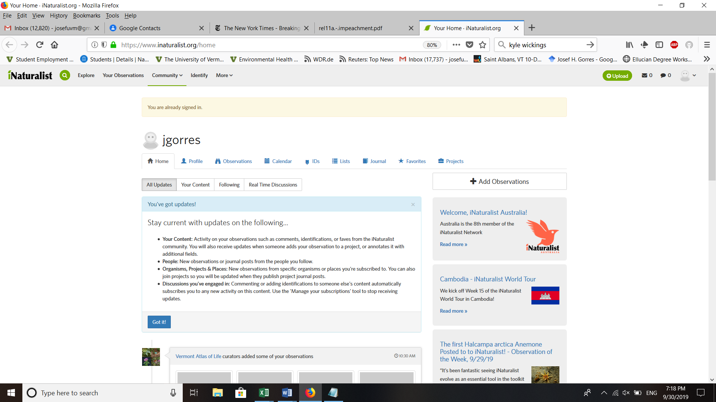
Once you are familiar with the main function “Observations” on the tabs at the top you can explore the page a bit more. But for now, its all about observations and how to enter them.

This is what the observation tab looks like. It gives you observations you have already entered into the program and you can also add more observations here when clicking the blue button at the top left had side of the page (circled blue).
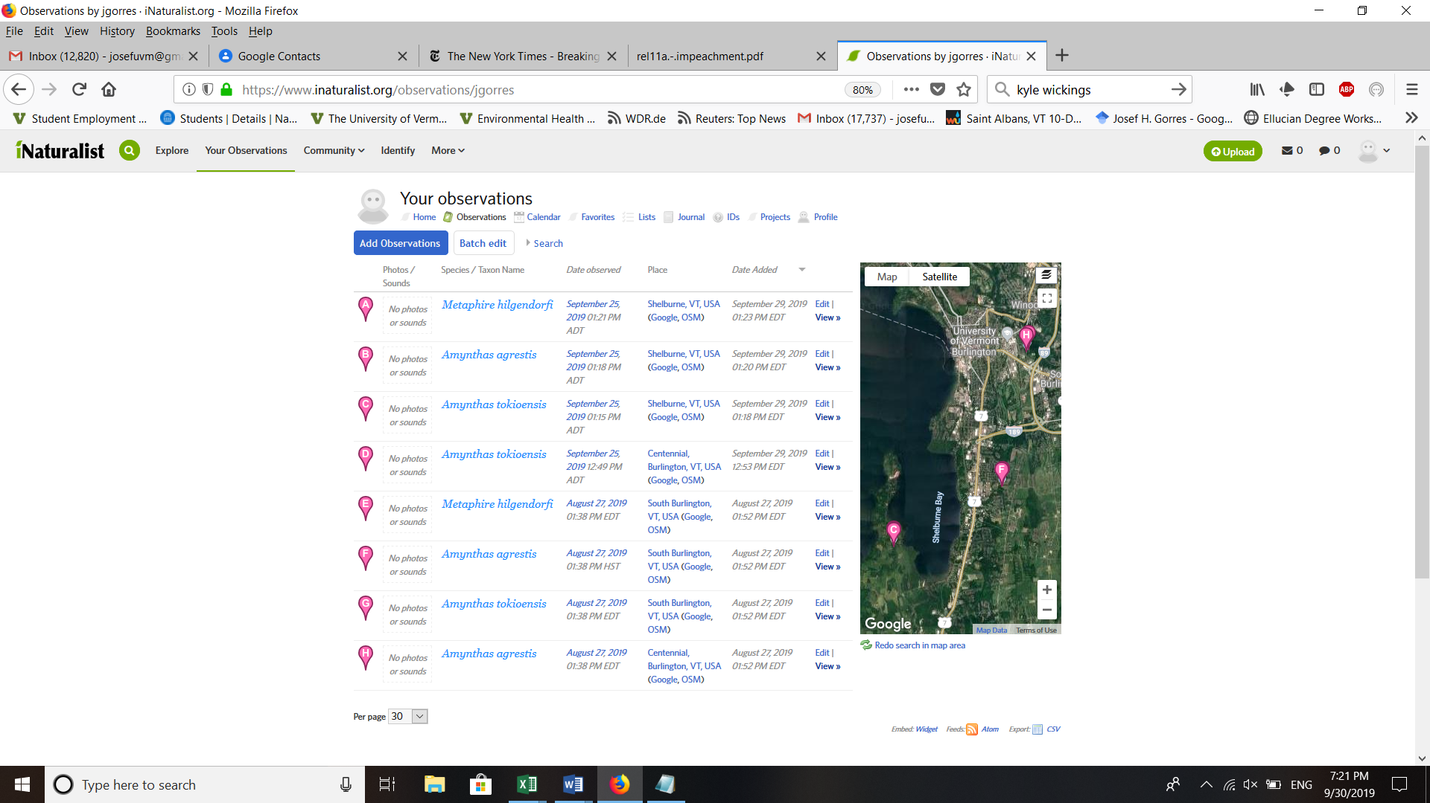
What does the program ask you? First you have to decide whether you are posting a picture or two, or whether you want to go without a picture?
Once you have dealt with this, another screen pops up… Here you enter coordinates, species names and any other detail you want. Zoom in on site where you found the worms to get the coordinates. If you go that route, click on the little place marker next to the textbox that is called location. Then a map of the world (see below) comes up with navigation + - zooms. You can also move the map around by clicking and dragging to center your location. If you are like me it will take a few times of zooming in and dragging. When you have the location you want click on the blue button “Update Observation”. This will enter the observation.
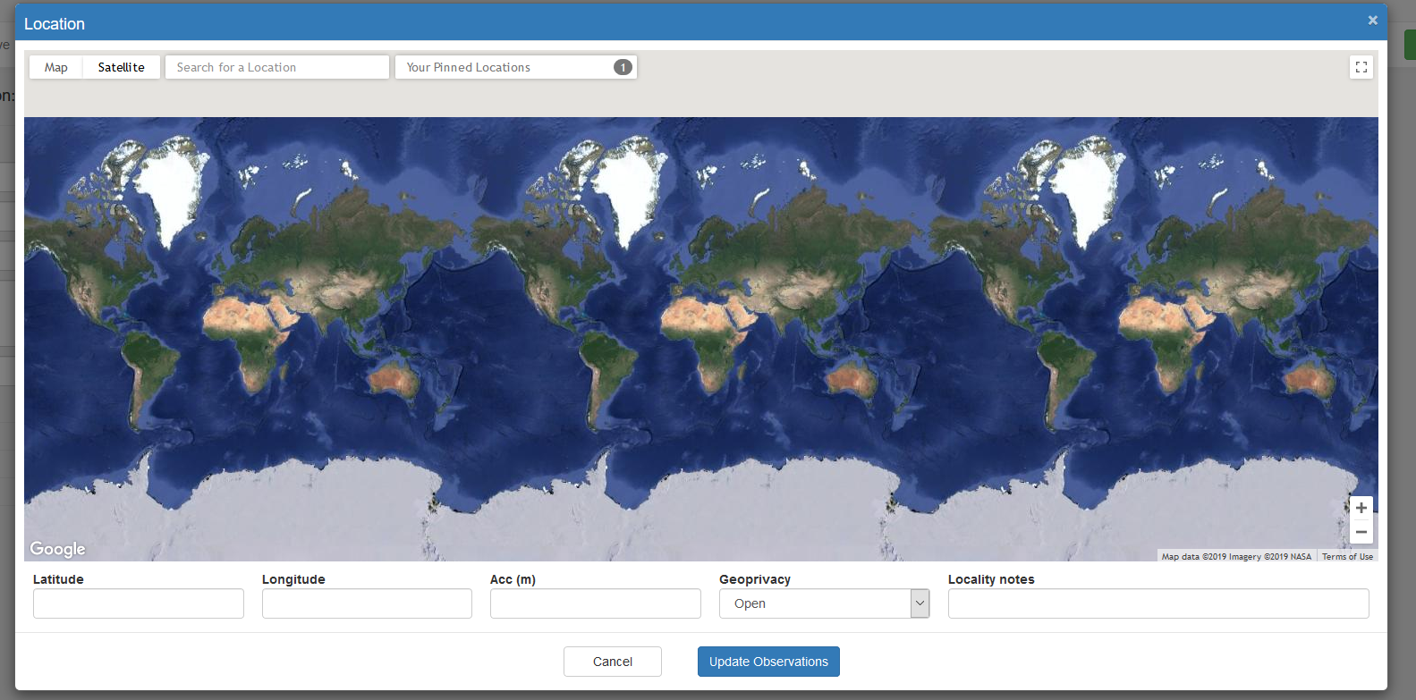
If you are not sure which species you have, but you are sure it is a pheretimoid, then just say “pheretimoid”. If you know what species, enter the species. A pheretimoid is easily distinguished from European species by the fact that the adults have a clitellum (ring around the neck) that is clearly off-set from the rest of the body by color and that goes around the entire circumference of the body. Usually, the worms also wriggle, jump and snake when you put them in your hand.

- Key to the three pheretimoid species in Vermont

- Is the worm an adult? i.e., does it have a clitellum?
  - Does the clitellum go all around the body? Yes, go to Pheretimoid
    - No European earthworm
- Pheretimoids (If unsure you can report this taxon)
- Is the worm shorter than 2.5 inches long and slim?
  - Yes, Likely Amynthas tokioensis
  - No, Is the worm longer than 10 cm?
  - Does the worm have two clear, distinct genital markings several segments
in front of clitellum? (visible to naked eye). Yes, then Metaphire hilgendorfi
  - Else, Amynthas agrestis.

