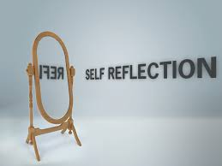
Women in Ag Programs for
21st Century Farms & Ranches:
Best practices & innovative approaches
for emerging audiences

November 29, 2016, Portland, Oregon

Reflective thinking turns experience into insight.
John Maxwell

Reflective thinking is the act of going back to an experience then making observations of, and meaning about, that experience. It’s also the act of asking yourself what you might do as a result.

Today, we will go back to comments of our speakers and reflect on:

- What was said by in which sessions? What resonated with your experience? What was different, or surprised you?
- What any or all of the comments mean to you?
- What you think you might do to apply this meaningful information?

Time will be provided for silent reflection between sessions. Use the “Reflections” sheet in your packet to record your responses. Take those thoughts home and review.

What you do then is up to you. Our “Action Planning” sheet is simple way to map out your next steps.

Follow-up Help? If you wish, you may send it to beth.holtzman@uvm.edu to request assistance from our project team in moving forward with your individual plan.

