**Subject Area Tutoring**



New Tutor Training

2012-2013

Table of Contents:

I. Tutoring at UVM: Our Programs and Procedures

II. How to Learn and What to Learn: Learning Styles

III. Organizing a Tutoring Session

IV. Working with Students

V. Logistics: Logging Sessions, Checking your Schedule, and HR Paperwork & Trainings

VI. Summary of What to Submit Per Session

**I. Tutoring at UVM**



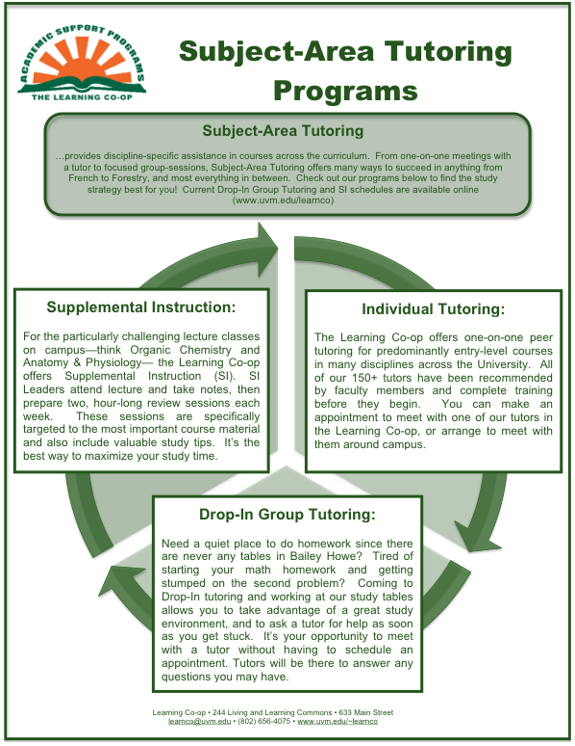

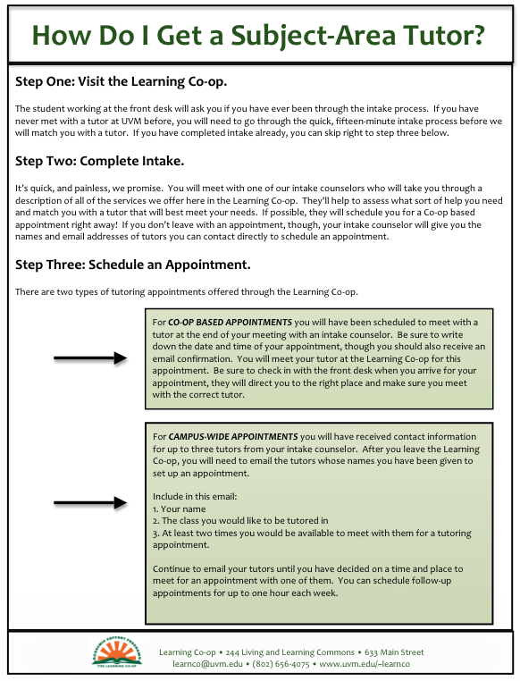

**Our Expectations:**

Wait, what did she say?

* What are the different ways a student can get help in Subject-Area Tutoring?

* What is the difference between Campus-Wide and Co-op based appointments?

* How often can a student meet with a tutor?



What can students expect of their tutors?

1. Respect.
2. That tutors will maintain the highest privacy standards in terms of protecting personal information in relation to those whom they tutor.
3. That tutors will respond to email and/or phone calls within a reasonable amount of time (within 24 hours).
4. That tutors are committed to acting in the tutees’ best interest, this includes never doing the tutees’ work. Tutors are not to work on graded homework assignments without the professor’s permission.
5. That tutors will practice and promote accuracy, honesty, and truthfulness.
6. That tutors will exercise reasonable judgment and take precautions to ensure that their potential biases, the boundaries of their competence, and the limitations of their expertise do not lead to or condone unjust practices.

What should tutors expect of students?

1. That you will come prepared to your tutoring session, this includes bringing your book and graded assignments, as well as attempted homework assignments and specific questions.
2. That all cancellations will be made to the tutor via email or phone well before the tutoring session. In this scenario, it is the student’s responsibility to reschedule. Please note that you may be charged for all appointments that you do not attend and do not cancel 24 hours in advance.
3. That you will respect the predetermined appointment duration, and respectfully renegotiate if necessary.
4. That you will come into the session understanding that the tutor will neither do the work for you nor assume the role already occupied by the course instructor or teaching assistant.

What can both tutors and students expect of each other?

1. Mutual respect for cultural, individual, and role differences, including those based on age, sex, gender identity, race, ethnicity, culture, national origin, religion, sexual orientation, disability, language, and socioeconomic status.
2. Tutors will arrive on time and be prepared for your tutoring session. In the case of tutor cancellation, he/she will email to reschedule. On the same note, students will also be on time and prepared. If the student needs to cancel, he or she must notify the tutor at least 24 hours in advance and make the effort to reschedule.
3. Maintenance of a professional and mature discourse during the session.

|  |  |  |  |  |
| --- | --- | --- | --- | --- |
| **Learning Styles Survey**  For each item, circle the number that best describes you, with 6 being most and 0 being least true. | | | | |
| 1. I prefer tasks requiring the operation, construction, or manipulation of objects or materials over ones requiring reading or writing. | | | 0 ⬜ 1 ⬜ 2 ⬜ 3 ⬜ 4 ⬜ 5 ⬜ 6 ⬜ | |
| 2. I seek an organized structure, want lessons to be clearly spelled out in step-by-step order, and want to know the teacher’s expectations. | | | 0 ⬜ 1 ⬜ 2 ⬜ 3 ⬜ 4 ⬜ 5 ⬜ 6 ⬜ | |
| 3. I keep a sharp focus on technical information and enjoy complex ideas. | | | 0 ⬜ 1 ⬜ 2 ⬜ 3 ⬜ 4 ⬜ 5 ⬜ 6 ⬜ | |
| 4. I learn best in face-to-face dialogue and enjoy discussing the content of lessons with a small group of peers. | | | 0 ⬜ 1 ⬜ 2 ⬜ 3 ⬜ 4 ⬜ 5 ⬜ 6 ⬜ | |
| 5. I focus on the immediate, am not interested in the past and future, and do not like to plan or prepare. | | | 0 ⬜ 1 ⬜ 2 ⬜ 3 ⬜ 4 ⬜ 5 ⬜ 6 ⬜ | |
| 6. I place high value on good study habits, enjoy completing workbooks, and like practice and drill. | | | 0 ⬜ 1 ⬜ 2 ⬜ 3 ⬜ 4 ⬜ 5 ⬜ 6 ⬜ | |
| 7. I like to experiment and invent, and enjoy analyzing and solving complex problems. | | | 0 ⬜ 1 ⬜ 2 ⬜ 3 ⬜ 4 ⬜ 5 ⬜ 6 ⬜ | |
| 8. I am satisfied with an overall grasp of learning and am not good at mastering details or searching for facts. | | | 0 ⬜ 1 ⬜ 2 ⬜ 3 ⬜ 4 ⬜ 5 ⬜ 6 ⬜ | |
| 9. I like competitive interactions more than cooperative ones and am more responsive to instructional games than lectures or discussions. | | | 0 ⬜ 1 ⬜ 2 ⬜ 3 ⬜ 4 ⬜ 5 ⬜ 6 ⬜ | |
| 10. I have difficulty grasping abstractions and do best when learning the practical aspects of a subject. | | | 0 ⬜ 1 ⬜ 2 ⬜ 3 ⬜ 4 ⬜ 5 ⬜ 6 ⬜ | |
| 11. I display a stronger desire to be capable and gain intelligence than to have freedom to act, social belonging, or meaningful relationships. | | | 0 ⬜ 1 ⬜ 2 ⬜ 3 ⬜ 4 ⬜ 5 ⬜ 6 ⬜ | |
| 12. I am interested in and seem to have superior insight into what people think, feel, or want. | | | 0 ⬜ 1 ⬜ 2 ⬜ 3 ⬜ 4 ⬜ 5 ⬜ 6 ⬜ | |
| 13. I respond to class work only when I find it to be fun and entertaining, and become inattentive if it requires study and concentration. | | | 0 ⬜ 1 ⬜ 2 ⬜ 3 ⬜ 4 ⬜ 5 ⬜ 6 ⬜ | |
| 14. I tend to be sensible, stable, and practical rather than imaginative, creative, or ingenious. | | | 0 ⬜ 1 ⬜ 2 ⬜ 3 ⬜ 4 ⬜ 5 ⬜ 6 ⬜ | |
| 15. I have a preference for long-term independent projects, which I can carry out with little teacher help. | | | 0 ⬜ 1 ⬜ 2 ⬜ 3 ⬜ 4 ⬜ 5 ⬜ 6 ⬜ | |
| 16. I enjoy the communication process and have a talent for expressing my feelings and thoughts. | | | 0 ⬜ 1 ⬜ 2 ⬜ 3 ⬜ 4 ⬜ 5 ⬜ 6 ⬜ | |
| Enter your rating (0-6) in the following space for each item (1-16). Total each column. The highest total represents your preferred learning style. | | | | |
| **SPONTANEOUS** | **ORGANIZED** | **CONCEPTUAL** | | **INTERACTIVE** |
| 1. | 2. | 3. | | 4. |
| 5. | 6. | 7. | | 8. |
| 9. | 10. | 11. | | 12. |
| 13. | 14. | 15. | | 16. |
| TOTAL: | TOTAL: | TOTAL: | | TOTAL: |

**II. How to Learn and What to Learn**



Learning Styles-

Tutoring a student is more than giving them the answer to a problem; it is a careful art of blending the mastery of subject-material with the methods of accumulating such knowledge. It is the integration of how to learn with what to learn. But not every student will learn the same way. Helping a student to be successful in a class requires patience and an understanding of how they learn best.

The following description of Learning Styles and accompanying Learning Styles quiz has been borrowed from the text *Learning and Motivation Strategies for Achievement*, page seven (Tuckman, Bruce W., Dennis A. Abry, and Dennis R. Smith. *Learning and Motivation Strategies: Your Guide to Success*. Upper Saddle River, NJ: Pearson/Prentice Hall, 2008. Print.).

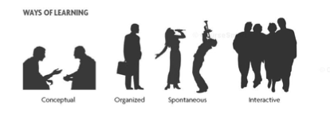

“People learn in at least four different ways. One way is *spontaneous*. This means learning from the experience of actually doing something, without it necessarily being in a teaching-learning situation. You may have learned to ride a bike this way, by just hopping on and pushing the pedals as quickly as you could. You may have fallen off a few times, but soon you got the hang of it.

Spontaneous learning is physical learning, which means it requires hands-on manipulation and actual performance. The motivation for spontaneous learning comes from the excitement of it, often brought on by competition, risk, adventure, and the enjoyment of performance. Spontaneous learners, that is, people who prefer to learn this way, like action and the freedom to act, and tend to be easily distracted when in passive learning situations, like a typical classroom.

The second way is *organized*. Organized learning, and the student who prefers it, require structure, sequence, and advance notice. A good syllabus and clear requirements are musts. Great opportunity for practice, frequent assignments, and clear grading criteria are equally important. Repetition and explanation are preferred.

The third way to learn is *conceptual*. Conceptual learners require the opportunity to work independently, to pose questions and seek answers, to collect and classify data, to solve complex problems, and to try to understand, explain, and predict what they encounter.

The fourth way is *interactive*. Interactive learners require the opportunity for interaction and communication with other people. They prefer subjects that deal with people and call for a personal focus, rather than more technical or detail-oriented ones. They have much less interest in detail than on larger meaning. The like to create, to speculate, write, and interpret.”

***So What?***

* After taking the Learning Styles test and determining your Learning Style, re-read the descriptions of each style above. Which characteristics do you most identify with, and which don’t seem to fit?

* Think back to a class that was particularly difficult for you. How might your preferred Learning Style have contributed to the difficulty or your dislike of the course?

* How might you benefit from elements of each of the Learning Styles?

As a college student, it is up to you (and your students) to adapt your study methods for a course to your own Learning Style preferences. You may be a spontaneous learner stuck in a 300-person lecture or your tutee could be a conceptual learner in a rigidly structured recitation. It is up to you as a student and as a tutor to recognize your strengths and preferences and to create a study plan that allows you to be successful in any situation.

* For example, consider how effective each of the following activities would be for your learning style: keeping logs or journals, participating in small group discussions, doing math problems with a group of friends, making a group sculpture, listening to teacher directions, writing papers, going on a walk around campus, studying for a unit test, or another type of academic work?

* How could you address a student’s Learning Style in a session? What would you do to create an ideal learning environment, and how could you teach them to implement these methods during their individual study time?

**III. Organizing a Tutoring Session**



The following chapter from the book *Becoming an Effective Tutor* (Myers, Lynda B. "Lesson Three: Coaching Tutees to Win." *Becoming an Effective Tutor*. Los Altos, CA: Crisp Publications, 1990. Print. p7-10.) outlines a solid strategy for approaching the organization of a tutoring session.

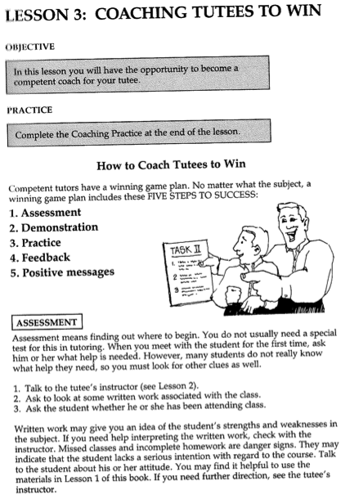

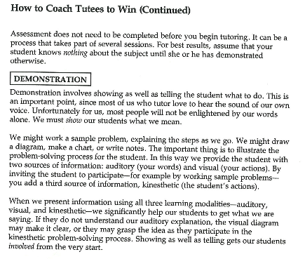

Take a moment to digest…

* What sort of questions could you ask to assess a student’s level of comfort with certain class material?

* Taking an assessment at the beginning of the session is closely linked to setting goals for your time with the student. A good goal will be challenging, yet attainable, and clearly defined. List a few good goals for a tutoring session.

* How could you incorporate your knowledge of different Learning Styles into your methods for demonstrating course materials and study techniques during a session?

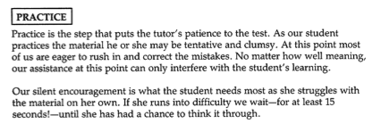

Practice makes perfect.

* Especially for problem-based courses (math, chemistry, etc) it is of the utmost importance that students practice the skills and concepts you have worked on together. This means actually doing problems without the help of the tutor. What are some ways you can incorporate practice into your sessions?

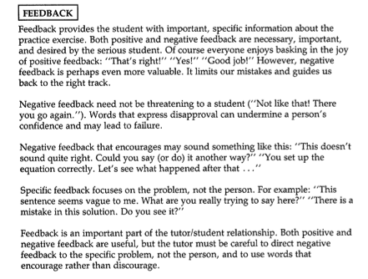

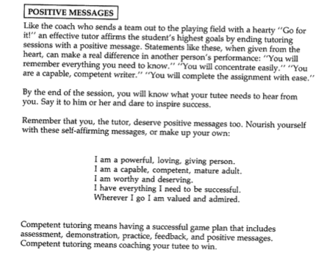

Positive Thinking.

There are multiple ways to give positive feedback and encouragement to students. **Positive verbal reinforcement**, such as the comments “good,” “fine,” and “excellent” allow a tutor to immediately indicate satisfaction with a students response. These are most effective when varied and used intermittently. **Positive nonverbal reinforcement**, like a nod or smile, is also reassuring to a student. This also includes maintaining a posture that displays respect and interest, maintaining eye contact, and facing a student. **Qualified reinforcement** allows the tutor to reinforce separate parts of a response, drawing attention to the positive aspect of a response while guiding the student to amend incorrect thinking. Finally, **delayed reinforcement** allows the tutor to hearken back to a student’s earlier success and build upon these skills or concepts.

* Now list a few examples of effective feedback and positive messages you can send students during a session:

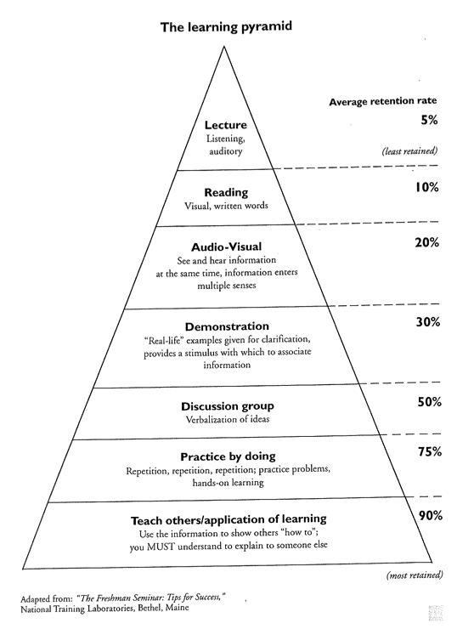

**IV. Working with Students**

One step further…

* How do the concepts outlined in the Learning Pyramid reflect the strategies we discussed for organizing a session?



“Effective helpers trust that others have the necessary human resources to discover and implement solutions to their problems, and act as guides along the path of exploration, understanding, and problem resolution.”

-(Ender, Steven C., and Fred B. Newton. *Students Helping Students: a Guide for Peer Educators on College Campuses*. San Francisco: Jossey-Bass, 2000. Print. p 85.)

“Respect is the belief in the capacity of the people seeking help to help themselves and can usually be demonstrated by good attending behavior, refraining from doing anything for people that they could do themselves, and supporting people in their efforts.”

- Ender, Steven C., and Fred B. Newton. *Students Helping Students: a Guide for Peer Educators on College Campuses*. San Francisco: Jossey-Bass, 2000. Print.

A Safe Space.

* It’s not always easy to ask for help. While it may seem like idle chatter, taking the time to get to know your student at the start of a session is worth every minute. Use this space to brainstorm ways you can make your tutoring session more welcoming and encouraging for your student:

Helpful Hints for Tutoring English Language Learners

*Below are some quick-tips to assist you when working with English Language Learners:*

1. Create an atmosphere where the student feels accepted

* The more comfortable a student feels with the tutor, the less anxious he or she will feel about speaking, making mistakes, and learning.
* Focus on the positive and introduce the student to his or her surroundings (for example, show the student a tour around the Co-op)

1. Do not assume that the student has been introduced to the American style of writing

* You may need to cover the structure of an academic paper

1. Prioritize the session

* There may be a lot of questions or material to get to in a short period of time. If necessary, address the major issues first and set up an additional appointment if necessary.
* Setting goals may be appropriate so that the student also has an agenda and knows what to expect from the session.

1. ELL students are most likely to make errors with articles

* This is a particular issue for Asian or Russian students, whose languages do not use articles.
* The basic rule is: countable nouns require articles and uncountable nouns generally do not. Using a concrete noun requires a definite article, but reference to an abstract noun usually requires an indefinite article.
* However, problems arise because some article use is idiomatic.

1. Don’t “fix” it

* Explain to the student WHY a change is being made in his or her work rather than just fixing it without explanation
* If you can’t find an explanation for an error, particularly a grammar mistake in writing, don’t lie.

1. Don’t dominate the session

* Often, ELL will be shy to speak, ask questions, or interrupt. Asking questions, engaging the student, and challenging the student will enable the ELL to improve his or her English, receive assistance in the class, and make the session a two-way street.

1. When tutoring math, be aware of cultural differences

* Decimal and comma usage varies by culture
* The U.S. measurement system is different than the rest of the world’s

1. Check your speed

* Ask your student if your speed of talking is okay. This will ensure that the student can understand you. If an ELL student does not understand you, he or she may be afraid to ask you to slow down.

**V. Logistics**



**Sexual Harassment Training: HR will get in touch. Must provide a certificate of completion.**

**Faculty Recommendation:**

Before you can begin working in the Co-op, you will need to request a faculty recommendation for each course you wish to tutor. To obtain the necessary faculty recommendation to work as a Subject-Area Tutor in the Learning Co-op, or to add a new class to the list of courses you can tutor, send the following link to your Professor for the course.  A survey will appear when it is opened and, upon completion, the finished recommendation will be automatically sent to the Learning Co-op. [http://www.uvm.edu/~learnco/sat/facrec/](http://www.uvm.edu/%7Elearnco/sat/facrec/" \t "_blank)

If you or your professors have any difficulty with completing the recommendation, please contact Keith Williams, Tutor Program Coordinator (656-7964/Keith.M.Williams@uvm.edu).

***Weekly updates, important links, and instructions for logging sessions and entering hours can all be found on the subject-area tutoring blog:***

**http://blog.uvm.edu/subtutor/**

**What to Submit for each type of appointment:**

**Campus-Wide Appointments:**

1. Create a “Quick Visit” in TutorTrac to create a record of the session. Be sure to fill in all of the fields.
2. Enter the hours you have worked into PeopleSoft. Be sure they match the date and number of sessions you have reported in TutorTrac.

**Co-op Based Appointments:**

1. Be sure to check your schedule on TutorTrac no more than an hour before your scheduled availability.
2. When you meet with a student, return to your schedule to mark the session as attended and to complete your notes in the session record.
3. Enter the hours you have worked into PeopleSoft. Be sure they match the date and number of sessions you have reported in TutorTrac.

**Drop-In Group Tutors and SI Leaders:**

1. You will need to have all students sign an attendance sheet for each session you have. We will log the sessions into TutorTrac here in the Learning Co-op; you do not need to do this.
2. You will need to submit a work summary report before the end of each pay period.
3. Enter the hours you have worked into PeopleSoft. Be sure they match the date and number of sessions you have reported in TutorTrac and on your work summary report.

**Work-Study Tutors:**

1. Follow the directions as indicated above.
2. For Co-op based appointments, remember you are required to show up and get paid for all availabilities, even if no one schedules an appointment with you.
3. You will need to complete a paper work summary report (found by the printer and on the blog) each week and submit it to Keith.
4. You will need to enter your hours into PeopleSoft weekly.