Rachel Garwin
PBLA
4/18/11

Jericho’s Japanese Larch Plantation:
A Telescoping View from Prehistory into the Future

Standing in the center of the towering Jericho Research Forest (JRF) today, I would never know that sand would be blowing by my ears if I had stood there merely seventy years ago. Instead of bare sand dunes, a patchwork of forest types covers this 478-acre property, now owned by the University of Vermont (UVM). The stands are so small and so varied that walking through the forest is continually surprising. One moment I walk through a native northern hardwoods assemblage, the next I’ve crossed into rows and rows of white pines. Even stranger are the exotics—bright orange trunks of Scots pine, the gauzy crowns of Japanese larch, and even a couple of puzzle-barked ponderosa pines. Old logging roads crisscross the forest as well; though some are more permanently etched into the sandy soil than others. All forests transition—current ecological theory speaks much more about dynamism and change than climax stages or stable equilibria—though JRF and other Vermont lands recovering from intensive agriculture may be transitioning more dramatically than most. The exotic plantations, in particular, approach the end of their usefulness, and land managers across the region have begun to wonder what to do with these remnants of forest management practices from long ago. The question, “What do we do with the plantations?” was a recurring theme throughout our conversations with forest managers.
Reconstructing the story of a place from bedrock geology, surficial geology, soils, vegetation, animal communities, and human use is a common practice among some circles. Both the Field Naturalist and Ecological Planning Program at UVM and the Place-based Landscape Analysis and Community Education (PLACE) Program use this approach to understanding the world around us. Both programs usually operate on a landscape, town, or site level. Such analysis results in an integrated description of how a place functions, from physical and ecological processes to human community interactions. Applying these techniques on a stand level, however, is much harder due to the nature of available information. While bedrock and soil maps are easily interpreted given a precise location, translating historical ecological descriptions from the regional to tens-of-acres scales can be difficult or even flat wrong. However, since managers often make stand-by-stand decisions, tracing the prehistoric and historic story of an individual stand may prove instructive. To this end, I have focused on JRF’s main Japanese larch plantation, a fourteen-acre square in the dead center of the property (Figure 1).
Below the Japanese larch plantation (hereafter the “stand” or “site”) lay the non-calcareous slate, greywacke, and conglomerate of the Pinnacle Formation (GIS analysis). The Laurentide Ice Sheet covered the site sometime after it began growing 100,000 years ago in northern Quebec. No visible evidence of the glacier’s advance remains in the stand, but plenty remains of its retreat. Beginning 12,500 years ago, the ice block retreated sufficiently north to clear the Champlain Valley of ice. Meltwater from stranded chunks of ice streamed into the bathtub-like valley, whose northern drain was still plugged by the slowly shrinking ice sheet. Water levels rose, creating the freshwater glacial Lake Vermont, which rose to a maximum height of 600 to 620 feet (PLACE n.d. and L. Thompson, pers. comm., respectively) and flooded the foothills of the Green Mountains, including Jericho. In fact, the lake edge would have bisected the Japanese larch plantation, leaving a sandy beach above and below the line between water and land (Figure 2). The surficial deposits still reflect their glaciolacustrine origin: a wide band of sand serves as parent material to the soil above. The soils themselves indicate deposition alongside or in glacial Lake Vermont, as well. About half of the stand is mapped as Adams and Windsor Loamy Sands, while the other is mapped as Duane and Deerfield Soils (Figure 3). Adams soils developed in sandy beaches, deltas, and terraces; Windsor soils developed in water-deposited sand (SCS 1974). Duane soils developed in water-deposited sands; Deerfield soils formed on sandy deltas, beaches, and stream terraces (SCS 1974). Indeed, digging soil pits in on the site in the early spring evoked memories of building sand castles on the edge of the ocean; the walls even thunked hollowly when I slapped them with the flat of the shovel (Figure 4).
As the ice retreated farther, Lake Vermont was inundated by sea water and became the Champlain Sea, though the larch stand bears no witness of this transition. Little by little, however, we may presume that the bare sands were colonized by herbaceous plants, then shrubs and trees. Their decomposing remains added an organic layer that mixed with mineral products from the sand beneath; these mixed to create layers of soil. These, of course, are only generalized impressions of what may have happened. It is difficult to map large-scale, regional patterns of post-glaciation vegetation changes to a single fourteen-acre site. However, it is possible that boreal trees such as spruce (Picea), tamarack (Larix larcina), and fir (Abies) colonized the area quickly. Macrofossil evidence suggests that they were at least in the northern New England region by 12,000 years ago (Jackson et al. 1997). Whichever species moved in, however, organic soil continued building and forest assemblages continued transitioning.
We pick up the Japanese larch site’s story in the “presettlement forest” stage, just as the British governors were granting towns to enterprising colonists in the 1760s. Cogbill et al. (2002) identify the 1700s as an appropriate baseline for assessing forest changes due to a variety of land use changes. As such, researchers have exerted great efforts collecting and analyzing forest composition data ascertained from town-level records, including town line surveys, witness tree data, and written descriptions of the forests (Siccama 1963; Siccama 1971; Cogbill et al. 2002). Not only do these compiled data offer great insight into the regional characteristics of the time, but they might be able to describe the historic conditions of the greater town landscape in which the Japanese larch site is situated.
Unfortunately, Siccama (1963) wasn’t able to find town survey records for Jericho (he notes elsewhere that some records were lost or burned). Based on soil type, however, he extrapolated that a northern hardwood-spruce-hemlock covered most of Jericho (Siccama 1963: 78-79). Jericho Research Forest, however, occupied the southeastern corner of the arrowhead-shaped town that was likely occupied by a northern hardwoods-hemlock-white pine forest (Siccama 1963: 78-79). Unlike current composition, American beech would have made up a dramatic part of this northern hardwood forest. Beech made up 54.6% the trees identified by land surveys in presettlement forests in the 500-1000 foot elevation range (Siccama 1963: 58), though they only accounted for 35.6% of forests on Adams loamy fine sand (Siccama 1963: 59). The discrepancy is likely due to the abundance of pine trees in the sand deltas near present-day Burlington and Colchester (Siccama 1963). Additionally, Siccama (1971) states that hemlock and white pine appeared in equal numbers in the northern hardwood forests in the sandy terraces in Jericho, among other towns along the Winooski River. Even though we have no specific town data points for Jericho’s presettlement forest conditions, it seems reasonable that it would follow the northern hardwoods-hemlock-white pine forests mapped on similar soils in the region.
Written historical records, however, give an impression of great variability across the town of Jericho. Thompson (1842) states, “Soil and timber is various in different parts of town.” Child (1882-1883: 224) adds, “[Jericho’s] timber, too, is various, though mostly beech, birch and maple, interspersed with hemlock, cedar, pine and spruce, with some oak and ash.” The early impression of the forest was one of a “trackless wilderness” and “dense primeval forest” (Child 1882-1883: 227). Though Hemenway’s (1868) account is comprised almost entirely of social and ecclesiastical gossip, the local author does mention an abundance of bears, suggesting adequate habitat for the large mammals. Thus the historic information about Jericho is much like the landscape itself: patchy and varied. However, we do know that the Japanese larch plantation was almost definitely forested, and likely covered by a northern hardwoods-hemlock-white pine forest.
The Thompson family cleared this very forest in 1790 to build their farm. The stand is only very gently sloped and relatively near the farm buildings (less than two tenths of a mile), making it easy pastureland. The Thompsons worked the land as subsistence farmers with a small dairy operation and two sizeable orchards, and the younger generation’s expansion of the dairy operation significantly degraded the soil (Forrer 2005). In 1851, the Thompsons sold the farm to the Tarboxs, who transitioned most of the farm into sheep pasture and used the rest as a woodlot (Forrer 2005). The farm changed hands a couple more times until the infertile, sandy soils were completely exhausted and literally blowing away. In 1937, the Soil Conservation Corps partnered with the Bashaw family (the owners at the time) to develop a soil management plan in order to restore agricultural productivity to the blowing sand dunes (Forrer 2005). Non-native and native trees were planted in order to conserve soil, but no change was seen in two years. The Bashaws gave up the farm to a previous owner, who sold it to the City of Burlington in 1941 (Forrer 2005). In that same year, the University of Vermont swapped a parcel of land that would become today’s Burlington Airport for the farm.
After the University acquired the land, it focused intently on soil conservation research by planting all manner of trees in order to determine which would grow the fastest and conserve the most soil. As such, non-native species—including our Japanese larch—were planted as well as red and white pines. In all, sixty-five acres were turned into plantations (Forrer 2005). This land use history is integral to understanding the present and future of JRF, argues John Shane. He emphatically pointed out that JRF “[wasn’t] growing trees, [it was] actually growing soil” (J. Shane, pers. comm.).
And grow soil it did. Walking through the Japanese larch stand today, the blowing dunes are far from my mind. Instead a layer of needle duff cushions my feet, and a carefully dug soil pit reveals a thin layer of slimy, sparkly organic soil. The smell is rich and earthy, unlike the arm’s length of sand beneath. Above wave the gauzy arms of the Japanese larch (Figure 5)—trees from half a world away. At my level, however, hardwood saplings are evenly distributed among the larger larch trunks. Red maple mostly, though a few ashes’ candelabra-like branches make them conspicuous. A handful of beech saplings color the edges of the stand with last year’s papery, rasping leaves, and a solitary yellow birch avoids notice until almost the last moment. The snows just melted, the trees have not yet leafed, and tree identification is not the easiest task. However, my overwhelming impression is that the hardwood forest is lying in wait. Indeed, GIS analysis using UVM Forestry Program data (n.d.) shows that the hemlock-northern hardwood forest and northern hardwood forest natural communities would feel right at home on this site (Figure 2). We return to our initial question: what to do, then, with the Japanese larch plantation, in light of its 12,500 year history?
First let’s consider the larch themselves. Their primary purpose—to stabilize and renew the soil—has been realized. According to Brendan Weiner (Coordinator of the Green Forestry Education Initiative and de facto coordinator of JRF, pers. comm.), the Japanese larch are nearing the end of their timber lives, and hardwood regeneration is on the verge of happening on its own. Other forests in the region, including the Green Mountain National Forest and the Marsh-Billings-Rockefeller National Historical Park (MBR), have faced similar questions and considered a bevy of solutions. I will present some of their considered options, as well as those that came to me as I wandered through the larch plantation, on a spectrum from least immediate management to most immediate management.

Possible Actions:
- No action: let the trees stand stand, allow natural processes to thin the trees and create gaps (MBR 2005); it might be a possibility to salvage fallen timber, as long as no damage to standing trees or soils occurs.
- Less action: let them stand, but periodically thin plantation to select for biggest, healthiest trees (Chris Casey, silviculturist for the Green Mountain and Finger Lakes National Forest, pers. comm.). Don’t do anything to regenerate the stand.
- Maintain exotic plantation for historic/timber purposes: Thin plantation to promote forest health while favoring most vigorous trees. When less than 75% of the historic trees remain, replace the plantations using the same species, in the same patterns for the historical value, tying to the history of the forest, maintain productive timber operation (MBR 2005).
- Maintain softwood plantation for timber purposes: Similar as above, but replace plantations using native softwood species, maintain productive timber operation.
- Gradually convert plantations to hemlock-northern hardwoods/northern hardwoods natural community: Grow the stand the end of its rotation and transition to northern hardwoods and conifers that appear naturally in the site. Management actions include periodic thinning to promote growth of healthiest, vigorous trees and allowing release of native hardwoods from understory (MBR 2005). Silviculturist practices that promote natural structure development (including coarse woody debris development, large standing snags, and uneven age classes) could also be employed (Franklin et al. 2002).
- Immediately convert plantations to hemlock-northern hardwoods/northern hardwoods natural community: Liquidate the stand, plant with new native species, while throwing in a variety of species that might increase the stand’s ability to withstand climate changes and pest invasions (i.e. high species diversity) (Chris Casey, pers. comm.).
- Whatever is done/not done to the timber resource and biological community of the stand, a hydrological assessment of the area should be performed. The soils were very wet with snowmelt (my soil pit actually filled with water within thirty minutes), and there were small streams running across the soil, as well as down wheel ruts in what looked like an old logging road.

Whatever the JRF managers choose to do, they must let their visions and philosophies for the forest guide them. Does Jericho Research Forest serve as a museum like Marsh-Billings-Rockefeller National Historical Park, and thus should teach UVM students and the public what the Vermont landscape used to be like, seventy years ago? If so, the managers might find most attractive the option of maintaining the Japanese larch in perpetuity, or maybe choose to replace it with another softwood species to stay true to the spirit of experimentation that dominated the forest in the 1940s and 1950s. If, however, it is deemed that MBR sufficiently fulfills that role, the Jericho Research Forest may yet fill others. If it is to be primarily a teaching site, the larch plantation could serve as a practice area for future sustainable foresters as they help perform shelterwood or group selection cuts that might favorably affect the small hardwoods below. If, however, the value of natural, native biodiversity reigns supreme (and money can be found to perform the action), perhaps the immediate liquidation action might be most appropriate. Even after the managers have chosen among these broad options, smaller choices will appear. To carefully navigate the myriad options, however, the actors must know why and for whom they are managing the forest.
Perhaps, instead of managing this Japanese larch plantation—and by its proxy, the whole Jericho Research Forest—for what we want to get out of it, should we think of continuing the forest’s trajectory over the last seventy years? As John Shane suggested, this property should not be thought of as a timber forest, but rather as an ecological restoration project (pers. comm.). In that light, the forest is only midway between blowing sand and healthy northern hardwood forest. The Japanese larch plantation and the other sixty acres represent a transition phase in the forest’s redevelopment, perhaps no more. If UVM is committed to finishing what the Soil Conservation Corps began in the late 1930s, Jericho Research Forest’s managers should consider which ways to best hasten the regeneration of a hemlock-northern hardwoods assemblage where the Japanese larch plantation now stands.
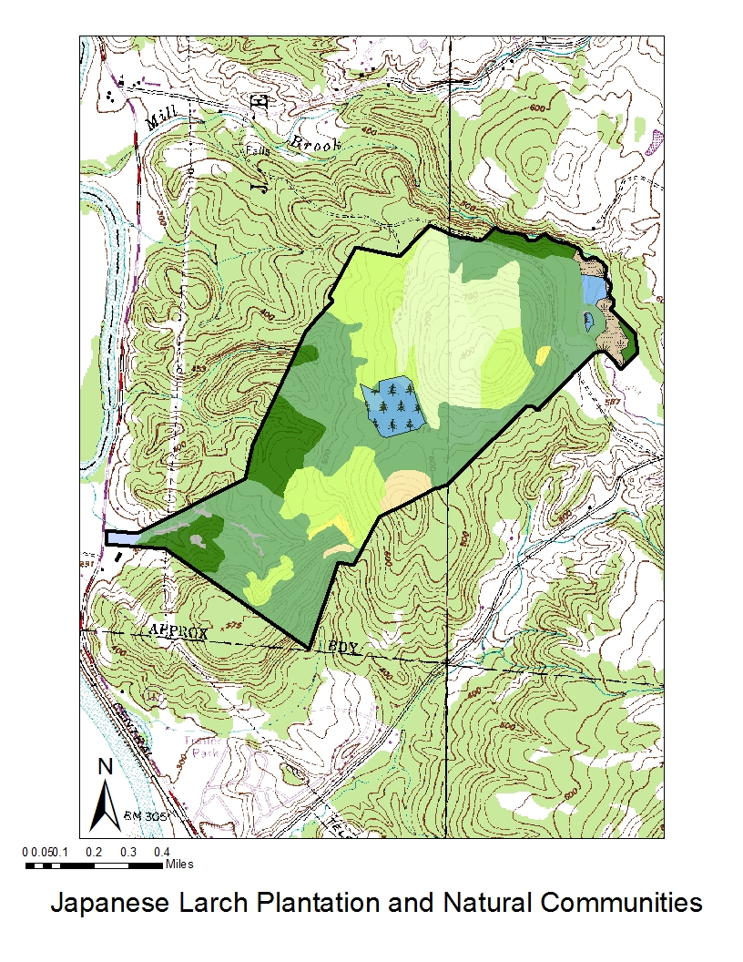
Figure 1. Map shows the outline of Jericho Research Forest, as well as the location of the primary Japanese larch plantation (blue square in the center of JRF). Shown also are the natural communities of Jericho Research Forest. Of particular note, A = hemlock-northern hardwoods forest, B = northern hardwoods forest. [NB: these are my first tries at making GIS maps so I acknowledge they’re a little rough.]
A
B
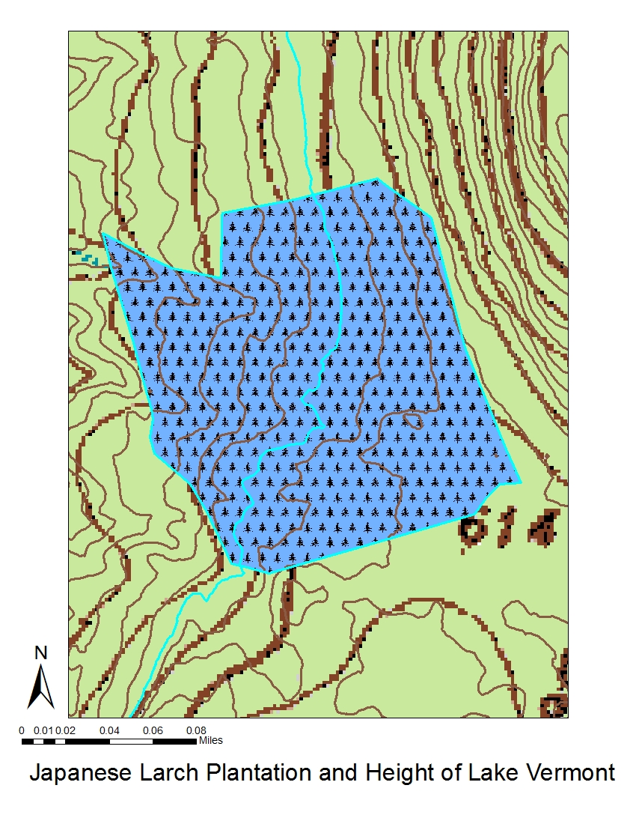
Figure 2. The Japanese larch plantation with a projected level of Lake Vermont, at 600 feet above sea level. The blue field with conifer cartoons shows the larch plantation, while the contour highlighted in aquamarine is the 600 ft contour. Contour distance is 10 ft, and the rest of the lake would have been to the west of the line.
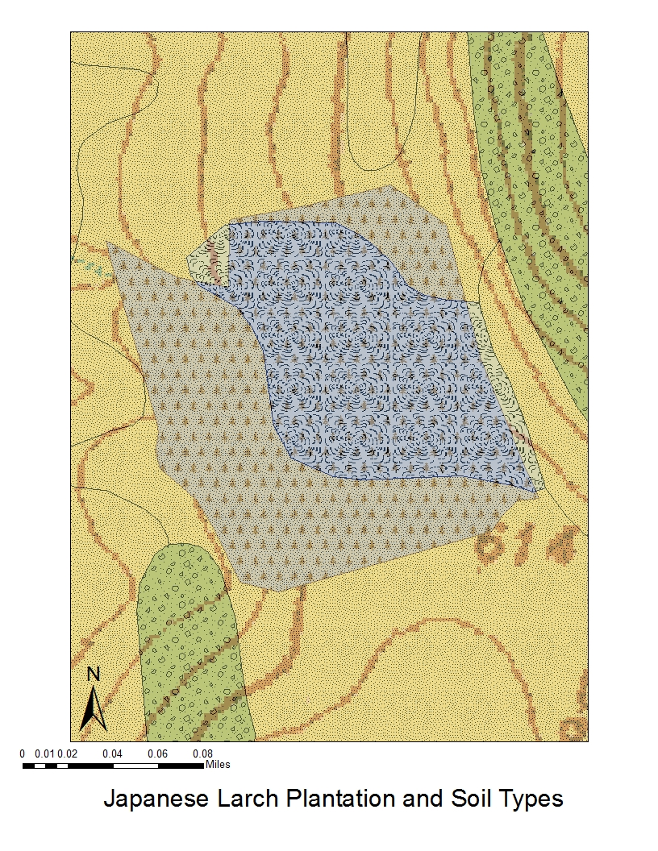
A
B
Figure 3. Soils mapped on top of the 14-acre Japanese larch plantation (the faded blue field with pine tree cartoons). A = Adams and Windsor Loamy Sands, 12 to 30 percent (though I think the slope must be inaccurate—it’s practically flat here); B = Duane and Deerfield Soils, 12 to 20 percent.
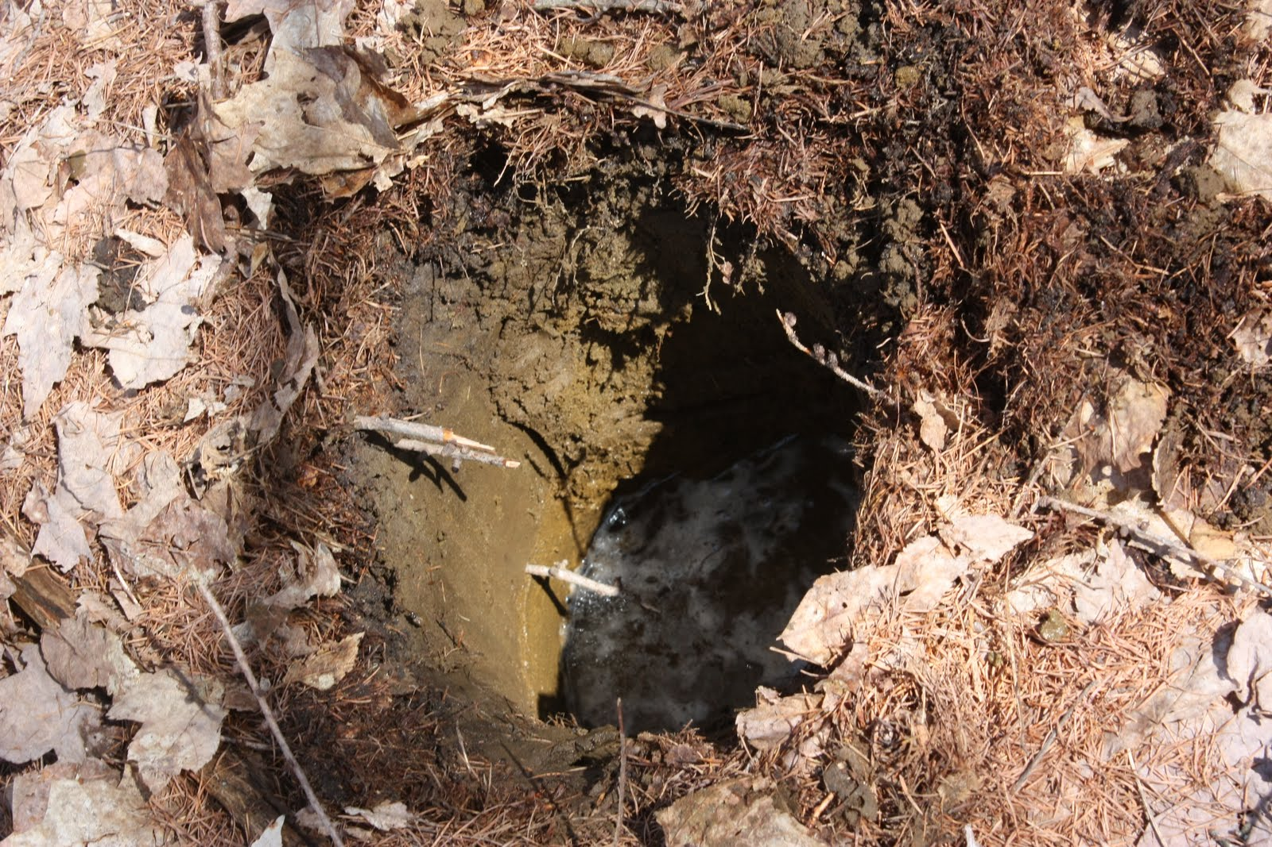

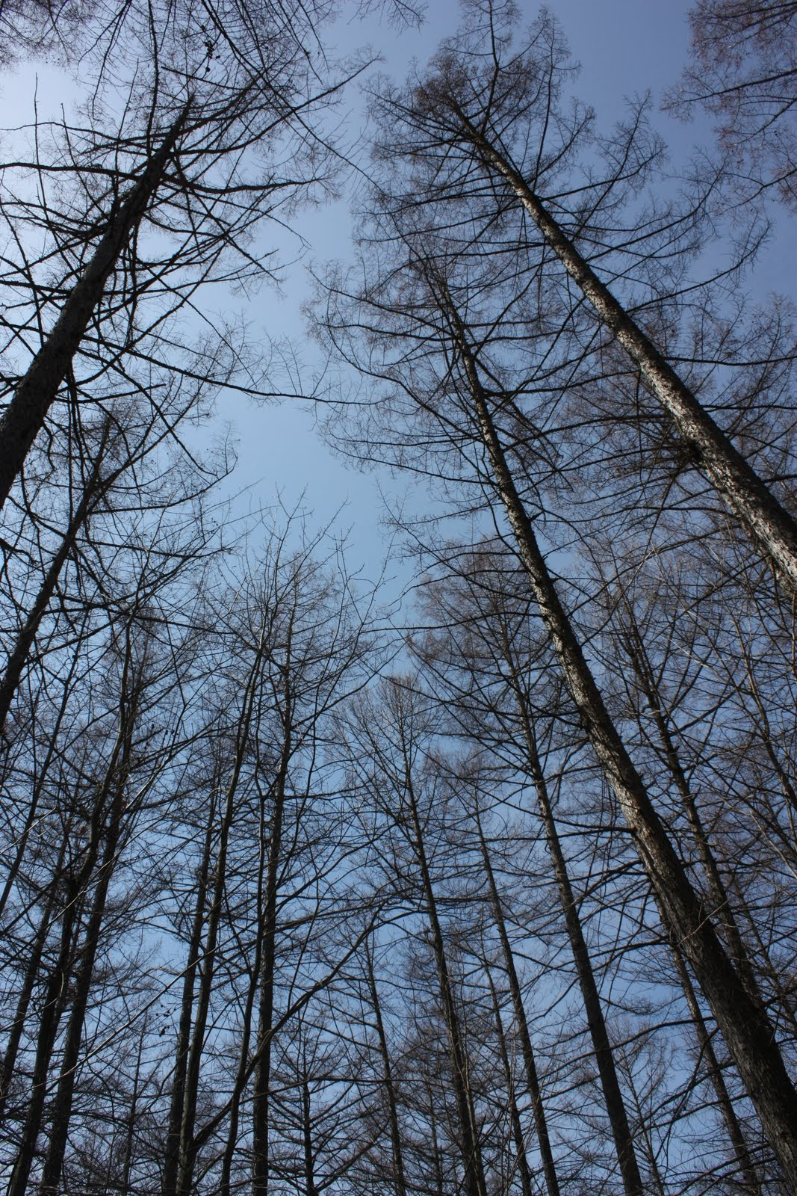
Figure 4. Soil pit dug April 9, 2011. Duff layer was 0.75”, organic layer 1.5”, brown sand layer (which I called a B, but could be an A_{p}) was 7.5”, and orange sand layer went as deep as I could get. Note freezing, frothy water beginning to fill the hole. Orange layer was saturated with meltwater. Photo R. Garwin.
Figure 5. Japanese larch reaching for the sky on a beautiful, clear April day. Photo R. Garwin.
References

Child, Hamilton. 1882-1883. Gazetteer and Business Directory of Chittenden County, Vermont, for 1882-1883. Syracuse, NY: Journal Office.

Cogbill, C.V., J. Burk, and G. Motzkin. 2002. The forests of presettlement New England, USA: spatial and compositional patterns based on town proprietor surveys. Journal of Biogeography. 29 (10/11): 1279-1304.

Forrer, K. 2005. Integrating sustainability into forest management planning of the University of Vermont’s Jericho Research Forest, Jericho, VT (M.S. project). University of Vermont, Burlington.

Franklin, J.F., T.A. Spies, R.V. Pelt, A.B. Carey, D.A. Thornburgh, D.R. Berg, D.B. Lindenmayer, M.E. Harmon, W.S. Keeton, D.C. Shaw, K. Bible, and J. Chen. 2002. Disturbances and structural development of natural forest ecosystems with silvicultural implications, using Douglas-fir forests as an example. Forest Ecology and Management. 155: 399-423.

Jackson, S.T., J.T. Overpeck, T. Webb-III, S.E. Keattch, and K.H. Anderson. 1997. Mapped plant-macrofossil and pollen records of late quaternary vegetation change in Eastern North America. Quaternary Science Reviews. 16(1): 1-70.

Marsh-Billings-Rockefeller National Historical Park (MBR). 2005. Draft Plan [Exact title/type is unknown due to lack of title page and/or headers and footers describing the document].

Place-based Landscape Analysis & Community Education (PLACE). n.d. PLACE: Jericho Town Analysis. < http://www.uvm.edu/place/towns/jericho/index.php> Accessed April 17, 2011.

Siccama, T.G. 1963. Pre-settlement and present forest cover in Chittenden County, Vermont. M.S. Thesis, University of Vermont, Burlington.

—. 1971. Presettlement and present forest vegetation in northern Vermont with special reference to Chittenden County. The American Midland Naturalist 85: 153-172.

Soil Conservation Service, United States Department of Agriculture (SCS). 1974. Soil Survey of Chittenden County, Vermont. Washington, DC: Government Printing Office.

Thompson, Zadock. 1842. History of Vermont. Chauncey Goodrich, Burlington, Vermont. Quoted in Siccama, T.G. 1963. Pre-settlement and present forest cover in Chittenden County, Vermont (M.S. Thesis). University of Vermont, Burlington.

UVM Forestry Program. n.d. FOREST: Forestry Online Resource Exchange of Sites and Tools – FOREST Field Sites: Jericho Research Forest. <http://www.uvm.edu/rsenr/forestry/sites/ jericho.php> Accessed April 17, 2011.

All GIS analysis performed using data posted to UVM’s FOREST data sharing site (UVM Forestry Program n.d.)
“Soil blowing” is, in fact, a concern listed by the SCS (1974: 27) for Duane and Deerfield Soils when they are not vegetated.

