January 11, 2015

Dear New England Grape grower/processor,

I hope all is well this winter. For several years the USDA NASS New England Field Office has annually estimated the production and value of production of New England fruit crops, with the exception of grapes. Many in the New England Grape Industry have requested that the same information be made available for grapes. We are now able to do so thanks to funding from the Connecticut Department of Agriculture; Maine Department of Agriculture, Conservation and Forestry; Massachusetts Department of Agricultural Resources; New Hampshire Department of Agriculture, Markets and Food; Rhode Island Department of Environmental Management, and Vermont Agency of Agriculture, Food and Markets.

We need your help in order to provide the most accurate statistics of the importance of grape production in New England. All know grape producers will receive a Grape Processing questionnaire and a Grape Production and Disposition Inquiry, one of which is enclosed with this letter. Please complete the questionnaires and return them in the postage paid envelope.

We will use data from the Grape Production and Disposition to estimate grape acreage, production, and average prices received. Data from the Grape Processing questionnaire will show grape utilization. A couple tips on completing the questionnaires:

- Since many growers also process their own grapes, all growers are also receiving the Grape Processing questionnaire. If you did not process your grapes or purchase grapes for processing then please make a note on the Grape Processing questionnaire that no grapes were processed.

- If your grapes are for home use only please report the quantity harvested in question 2 and the total acres of bearing grapes in question 5. Also make a note on both forms “all grapes for home use” and return the questionnaires.

I appreciate your help with this project. Your survey response will be kept completely confidential, as required by federal law. NASS safeguards the privacy of all responses and will only publish only State and New England level data from this survey, ensuring that no individual operation or grower can be identified. If you have any questions or need help in completing the questionnaires, please call me at 1-800-642-9571.

Sincerely,
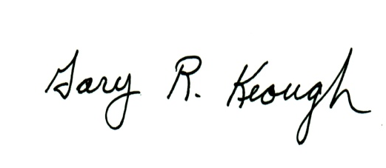

Gary R. Keough, State Statistician

