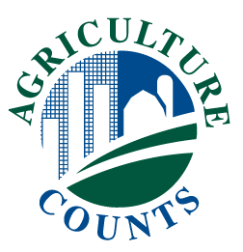**NEWS RELEASE**



United States Department of Agriculture

**NATIONAL AGRICULTURAL STATISTICS SERVICE**

**New England Field OFFICE**

**53 Pleasant St. Rm 3450, Concord, NH 03301**

|  |  |
| --- | --- |
| FOR IMMEDIATE RELEASE | Contact: Gary Keough |
| January 12, 2015 | (603) 227-3129 |

**USDA TO MEASURE NEW ENGLAND GRAPE PRODUCTION AND VALUE**

Concord, New Hampshire – According to the 2012 Census of Agriculture, the number of New England grape growers and the acres planted to grapes continued to show substantial growth over the last few years. To learn more about the trends of New England grape production, the U.S. Department of Agriculture’s National Agricultural Statistics Service (NASS) is now conducting the 2014 New England Grape Production and Processing Survey.

“The New England Grape Industry has been asking for more data on the types of grapes grown and the value of production,” said Gary Keough, State Statistician of the NASS New England Field Office. “This is an opportunity for New England grape growers and processors to provide more detailed data to that shows the economic importance of their industry.”

NASS will mail the survey in mid-January to all grape growers and processors in New England. The survey will look at the acreage, production, value of production, and utilization of the 2014 grape crop.

“The results of the survey will help show the importance of grape production in New England,” Keough noted. “In addition, the information can help producers make informed decisions about the future of their own farming operations.”

Recipients are requested to respond by mail by February 27, 2015. NASS will publish the results in April 2015. For more information about the New England Grape Production and Value Survey, call (603) 227-3129.

###

*USDA is an equal opportunity provider and employer. To file a complaint of discrimination, write: USDA, Office of the Assistant Secretary for Civil Rights, Office of Adjudication, 1400 Independence Ave., SW, Washington, DC 20250-9410 or call (866) 632-9992 (Toll-free Customer Service), (800) 877-8339 (Local or Federal relay), (866) 377-8642 (Relay voice users).*