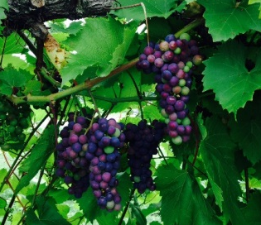
North Country Grape Industry
Advisory Meeting
With Dinner and Tour

Thursday, November 6, 2014
Willsboro & Keeseville, NY

You’re invited on a tour of on-going research projects and a meeting to advise the future of the cold-hardy wine grape industry in the North Country.
Cornell Cooperative Extension needs your input for determining the future of the grape industry in northern New York and Vermont! We invite you to participate in a tour of our grape variety trial at the Cornell Willsboro Research Farm followed by an advisory meeting. This meeting is open to wineries and current or prospective grape growers, interested in growing cold-hardy grape varieties.
Your input will be used to guide the future of the wine grape variety trial at the Willsboro Research Farm and Cornell Cooperative Extension’s involvement in the industry.
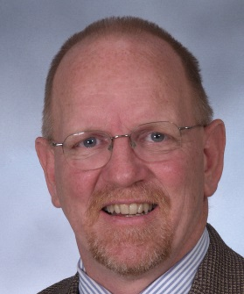
Agenda
Presentations will be given by Tim Martinson (left) CCE NY State Viticulture Specialist, Anna Wallis (below right) CCE ENYCHP Tree Fruit and Viticulture, and Terry Bradshaw (below left) UVM Tree Fruit and Viticulture Specialist.
2:00pm Optional Tour: Hid-In-Pines Vineyard
456 Soper St, Morrisonville, NY
NE SARE grant-funded trellising trial
3:30pm Optional Tour: Cornell’s Research Farm
282 Point Rd, Willsboro, NY
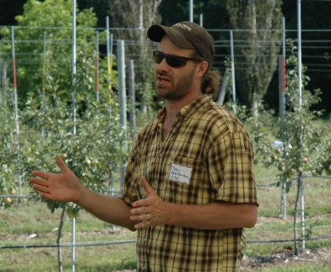
5:30pm Dinner and Advisory meeting at the
Whallonsburg Grange
1610 NYS Route 22, Whallonsburg, NY
- Overview of research conducted so far in the region
- Prospective research and role of Cornell Cooperative Extension, the CCE Eastern NY Commercial Horticulture Program (ENYCHP) and UVM Tree Fruit and Viticulture Program
- Round-table discussion: Future needs of the industry

Wine tasting following the meeting sponsored by Vesco Ridge Vineyards.
If you are interested in contributing a sample of your wine for the tasting, please contact Anna Wallis.

This program is being supported in part by the Northern Grapes Project. However, in order to help off-set the cost of dinner there will be a $10 registration fee. Please include payment with your RSVP.

Carpooling may be available. Please indicate in your RSVP if you are interested.

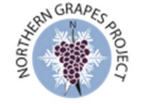
Questions? Contact Anna Wallis aew232@cornell.edu (443) 421-7970

North Country Grape Industry Advisory Meeting – November 6th 2014
RSVP and Questionnaire. Please complete and return by October 31st.
Please complete the following questionnaire and return with your RSVP information below. Responses will be used to guide a round-table discussion about the future of the Willsboro planting and Cornell Cooperative Extension’s involvement in the North Country grape industry. A $10 registration fee will help to offset the cost of catering and venue. Please make checks payable to ENYCHP.

Please describe your experience:
____ I am the owner of a licensed winery
____ I am an experienced winemaker, currently growing grapes but not licensed
____ I am an experienced winemaker, but not currently growing grapes
_____I am an experienced grape grower but not currently making wine
____ I am a beginning grape grower (less than 5 years of experience)
____ I am a prospective grower and do not currently have any vines planted

Describe your vineyard:
- Location: ___________________________
- Acres: ________________
- Varieties: ______________________________________________________________________
- Age of vineyard: ______________
Are you currently a member of a grape grower association? ____________________________________

Are you currently enrolled in the ENYCHP? Yes No

What types of workshops would benefit you/your operation in the future?

Have you taken the opportunity to visit the Willsboro planting? Yes No
Do you feel the Willsboro grape planting has benefitted you/your operation? Yes No
If so, how?

Would you like to see the Northern and Southern wineries coordinate more events together? _______

Rank the following locations (1 to 4) that you would be willing to travel to for seminars/workshops:
___ Plattsburgh ___ Capital District ___ Alexandria Bay
___ Willsboro ___ Geneva

Registration Information (please help us update our files)
Name(s): |  |  | Vineyard Name:
Street Address:
City: | State: |  |  | Zipcode:
Email: |  | Phone no:  Cell no:
I would be interested in carpooling: yes or no
_______ # attending @ $10 = $__________ enclosed. Please make checks payable to ENYCHP and return to:
Marcie Vanhoutka, CCE Renssalaer Co, 61 State Street Troy, NY 12180

