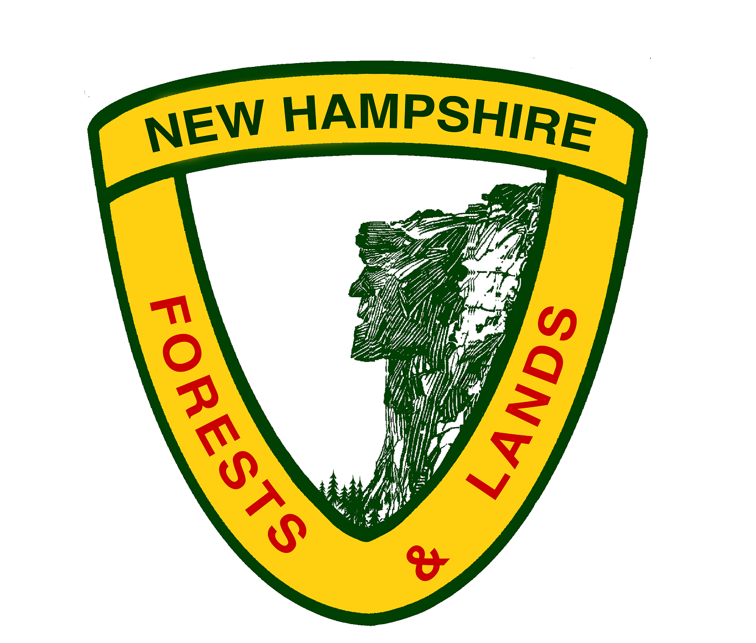

The Department of Natural and Cultural Resources, Division of Forests and Lands, has two full-time seasonal openings for twelve (12) weeks: beginning 5/25/18.

FOREST TECHNICIAN I

SNL #1168 & SNL #2109
(Forest Management Technician I)
(Labor Grade 10, $13.96 per hour)

The summer technicians will assist forest management staff conducting forest resource sampling and inventory at Nash Stream Forest, and occasionally assisting with timber harvest preparation and marking on other State Reservations. Applicants should be familiar with the use of compass, prism, and GPS. Duties require travel throughout the northern portion of the state. The use of personal vehicles will be expected. Applicants must posses a valid driver’s license and insurance as well as reliable transportation. Mileage will be reimbursed at the State rate of 54.5 cents per mile.

This position requires at least two years of formal forestry training from an accredited college or technical institute with major study in forestry or wildlife. No experience is required to apply. Students with only one year of formal training should still apply. There may be positions at a slightly lower pay grade.

The positions will be based at the North Region Headquarters in Lancaster, NH. For additional information, contact Maggie Machinist, Division of Forests and Lands, 629B Main St, Lancaster, NH 03584, (603) 788-4157 or margaret.machinist@dncr.nh.gov.

In order to be considered for this position, you must complete an official state application and provide transcripts. Employment application forms are available from the New Hampshire Division of Personnel web site http://das.nh.gov/jobsearch/Forms.aspx or by calling: (603) 271-3261/3262.

The completed applications are to be submitted with transcripts to Linda McFarland, HR, at 172 Pembroke Road, Concord, NH, 03301 or via email to linda.mcfarland@dncr.nh.gov

Application Deadline: Friday April 6, 2018.

THE DEPARTMENT OF NATURAL AND CULTURAL RESOURCES, DIVISION OF FORESTS AND LANDS IS AN EQUAL OPPORTUNITY EMPLOYER.

