JOB DESCRIPTION
 |  |  |  | 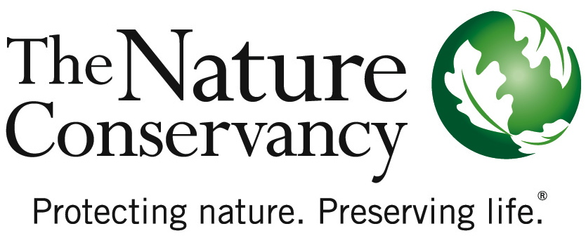
JOB TITLE | American Elm Technician
JOB FAMILY | Conservation
JOB NUMBER | 450002
SALARY GRADE | 2
STATUS | Hourly
DATE | Dec 13, 2016
SUMMARY | The American Elm Technician conducts field research and management activities in floodplain forest sites in Northeastern Vermont, near St. Johnsbury. This with include taking measurements, mapping and monitoring elm plantings. This work is part of a partnership with the US Forest Service to restore the wild population of American elm to its former role as canopy trees by developing and planting more disease-tolerant selections of American elm. This is a full time, short term position (approximately May 15 through August 31, exact dates are negotiable) that involves extensive outdoor physical labor in diverse weather conditions and may require working some weekends. The American Elm technician is supervised by the Floodplain Ecologist, Connecticut River Program, located in Northampton, Massachusetts and does not supervise other staff. Prior ecological or agricultural field research experience desirable but not required.
ESSENTIAL  FUNCTIONS | Duties will include, but are not limited to:  - Measure growth, survival and other monitoring data on elm plantings  - Enter monitoring data from past years into database and check for accuracy  - Map elm plantings with an IPad-based collector system and surveyor grade GPS  - Inspect and maintain labels on seedlings from elm crosses  - Maintain tree wrap on planted seedlings and other minor maintenance of planted seedlings  - Assist with planting seedlings  - Assist with propagation of exceptionally large surviving native elms
RESPONSIBILITIES & SCOPE | - Supervises no staff, but may help plan and direct preserve work groups, including staff or volunteers.  - May work in variable weather conditions, at remote locations, on difficult and hazardous terrain, and under physically demanding circumstances.  - Requires considerable physical exertion and/or muscular strain.  - Requires long hours in isolated settings.  - Makes day to day decisions as delegated by supervisor.  - May work under infrequent supervision.  - Consult with supervisor to develop plans for resolution of unusual or complex problems.  - Ability to function productively as a member or leader of a work team.
MINIMUM QUALIFICATIONS | - High school diploma and 1 year’s training in science-related field or related experience in land management.  - Experience recognizing plant and animal species.  - Experience operating various types of equipment.  - Experience working in a team environment.  - Must be able to obtain related licenses or certifications as required. (e.g. First Aid, CPR, herbicide application, and driver’s license).
PREFERRED KNOWLEDGE, SKILLS & EXPERIENCE | - 1 - 2 years’ experience in land management.  - Experience working with or knowledge of natural systems.  - Ability to recognize plant and animal species to complete preserve management activities.  - Ability to operate various types of equipment in a safe and efficient manner (e.g.; lawn mower, chainsaw, tractor, two-way radio, etc.).  - Ability to follow instructions from colleagues.  - PC familiarity, including database knowledge.
ORGANIZATIONAL COMPETENCIES | Communications | Effectively expresses messages verbally and in writing. Actively listens to others. Fosters open exchange of issues. Is timely with information.
 | Flexibility & Innovation | Flexible to changing circumstances. Takes innovative approaches towards work. Takes calculated risks and makes dependable decisions in the fact of uncertainty.
 | Interpersonal Savvy | Maintains positive working relationships. Contributes to productive partnerships inside and outside the organization. Understands team member roles and values the contributions of others. Effectively deals with conflict.
 | Open to Learning | Versatile learner and committed to self-improvement. Employs strengths effectively. Willingly shares knowledge with others. Seeks coaching on areas needing improvement. Adjusts behavior/performance as needed. Views mistakes as learning opportunities.
 | Organizational Awareness | Understands the basics of our business. Knows how local job relates to the big picture & contributes to the overall strategy. Knows how/why things work inside TNC. Easily moves through internal networks and channels for success.
 | Produces Results | Takes Initiative. Focuses on priorities. Strives for excellence. Is dependable and accountable for results. Persistent in the face of obstacles and meets deadlines.
This description is not designed to be a complete list of all duties and responsibilities required for this job.

