Free Onsite Tax Preparation Services

*Thanks to IRS certified volunteers through Working Bridges, employees who estimate they earned $54,000 or less in 2018 may be eligible for*

*free, basic tax preparation services.*



Free tax preparation services for UVM Custodial Services employees is available at the United Way of Northwest Vermont:

Monday, February 11th, 9am to 5pm

Monday, March 4th, 9am to 5pm

***Contact Lisa Jensen (***[***lisaj@unitedwaynwvt.org***](mailto:lisaj@unitedwaynwvt.org) ***or 802-922-6297)***

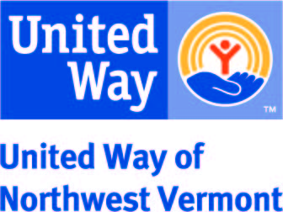



Lisa Jensen, Resource Coordinator

[lisaj@unitedwaynwvt.org](mailto:lisaj@unitedwaynwvt.org)

(802) 922-6297

Lisa Jensen, Resource Coordinator

[lisaj@unitedwaynwvt.org](mailto:lisaj@unitedwaynwvt.org)

(802) 922-6297

Lisa Jensen, Resource Coordinator

[lisaj@unitedwaynwvt.org](mailto:lisaj@unitedwaynwvt.org)

(802) 922-6297

Lisa Jensen, Resource Coordinator

[lisaj@unitedwaynwvt.org](mailto:lisaj@unitedwaynwvt.org)

(802) 922-6297

Lisa Jensen, Resource Coordinator

[lisaj@unitedwaynwvt.org](mailto:lisaj@unitedwaynwvt.org)

(802) 922-6297

Lisa Jensen, Resource Coordinator

[lisaj@itedwaynwvt.org](mailto:lisaj@itedwaynwvt.org)

(802) 922-6297

Lisa Jensen, Resource Coordinator

[lisaj@unitedwaynwvt.org](mailto:lisaj@unitedwaynwvt.org)

(802) 922-6297

Lisa Jensen, Resource Coordinator

[lisaj@unitedwaynwvt.org](mailto:lisaj@unitedwaynwvt.org)

(802) 922-6297

Lisa Jensen, Resource Coordinator

[lisaj@unitedwaynwvt.org](mailto:lisaj@unitedwaynwvt.org)

(802) 922-6297

Lisa Jensen, Resource Coordinator

[lisaj@unitedwaynwvt.org](mailto:lisaj@unitedwaynwvt.org)

(802) 922-6297