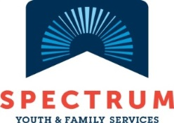
Multicultural Youth Program

Bike Club Summer 2018
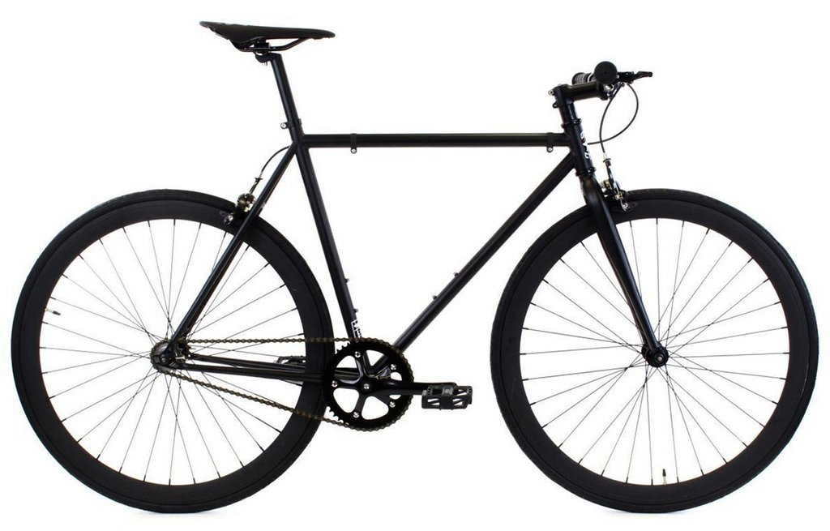
Youth ages 12-21 are welcome to join us for FREE biking, activities & chances to win up to 2 cool raffle PRIZES EACH PERSON!!!
July 16th – August 27th
Biking on Mondays or Wednesdays 12-3:30 & volunteering opportunities on Thursdays

To sign up Contact:
Yuol Herjok 802 734-9843  yyuol@spectrumvt.org | Katie Upton 859 324-1338  Kupton@spectrumvt.org | Noor 802-373-6074  nbulle@spectrumvt.org

