

**Resource of the Month**

**JULY**

**Crop Cash at Farmers Markets**

Community Events

**First Time Happy Camper Program**

Do you or someone you know want to try camping but aren't sure how to get started? Well, the First Time Happy Camper Program is just the thing. Vermont State Parks will loan you some gear, give you a free campsite and expert instruction!

[www.vtstateparks.com](http://www.vtstateparks.com)

**Free Outdoor Movie Festival**

**Ben & Jerry’s on Church Street**

**Tuesday nights 7/10 through 8/14**

All shows start at dusk. Bring your own chair! If you require special assistance in order to attend the movie, please call Ben & Jerry's at 802-862-9620

3SquaresVT households can match their benefits with Crop Cash to double their money at participating markets. How does it work? For every $1 a customer spends of their 3SquaresVT benefits, they will receive an additional $1 in Crop Cash, **up to $10** **per market day**. Ask your Resource Coordinator for a list of Farmer’s Markets or to see if your household is eligible for 3SquaresVT!

**Green Path**

Green Path provides free credit counseling, debt counseling, and financial education. Offers and clearly explains the low-cost debt management plan if that's an appropriate option for you. Provides specific counseling programs for housing and student loans. Some of the housing counseling and student loan counseling services have a fee. Contact your Resource Coordinator to learn how to connect with Green Path!

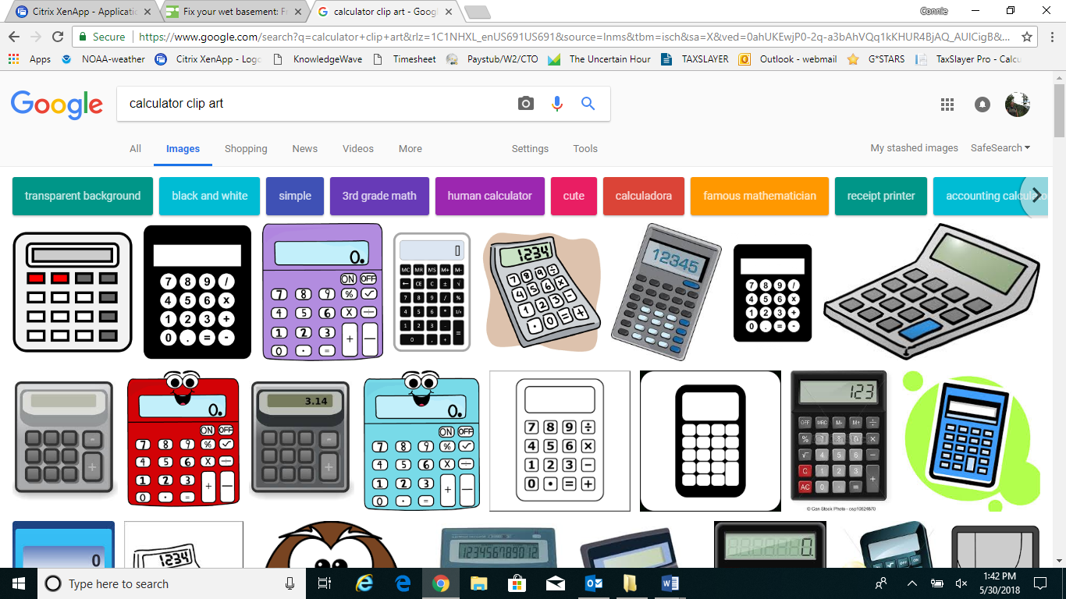**Thinking about buying a car or want to find a car repair shop?**

****Know your consumer rights before you shop around. In Vermont, the Consumer Assistance Program is your resource for understanding the laws that protect you as a consumer and can also help you if you are trying to resolve a problem with a business. For more information, call 1-800-649-2424 or go to [www.umv.edu/consumer](http://www.umv.edu/consumer). Contact your Resource Coordinator if you are having difficulty paying for a car repair.

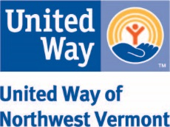

Contact Lisa Jensen

Working Bridges Resource Coordinator

**802-922-6297/ lisaj@unitedwaynwvt.org**

**Lisa is onsite for Custodial Services employees on Wednesdays**

**FREE CONFIDENTIAL ONSITE**