This document contains key messages related to hot weather and health impacts, organized by a variety of themes. These messages are intended to be used by Vermont Department of Health staff and its partners to provide consistent outreach to the media and public about heat illness risks and appropriate prevention and adaptation strategies.
Contents
Key messages (short) 1
Key messages (long) 2
Prevention guidance for individuals 3
Prevention guidance for communities 4
Prevention guidance for employers 4
Long-term adaptation for individuals 4
Long-term adaptation for communities 4
Heat illnesses - signs, symptoms, and first aid 5
Notes from heat analyses 6
Are Vermonters / Northerners at particularly high risk? 6
Who is at highest risk? 6
Why are children at greater risk? 7
Where do hot weather emergencies take place? 7
Urban heat islands 7
Heat vulnerability index 7
Heat acclimatization 7
Climate change 8
National Weather Service policy change 8
Social media posts 9

Key messages (short)
- Vermonters are at greater risk for serious heat-related illnesses, and even death, when the statewide average temperature reaches 87°F or hotter
- During the spring and early summer, hot weather can be especially harmful, since our bodies are still adjusting to the warmer conditions
- People at higher risk during hot weather include older adults and children, people active outdoors, people without air conditioning, and people with chronic medical conditions
- Learn the symptoms of heat illnesses and basic first aid – see page 6 below for more info
- Most heat illnesses can be prevented and treated through rest, shade, and water
- The number of days reaching a statewide average of at least 87°F is expected to increase in the future due to climate change

Key messages (long)
- Vermonters are at greater risk for serious heat-related illnesses, and even death, when the statewide average temperature reaches 87°F or hotter. Based on a statewide analysis of historical data, on days reaching 87°F or hotter:
  - heat-related emergency department visits occurred eight times more frequently
  - more ED visits occurred on hot days in spring & early summer than in late summer & fall
  - ED visits were more common for adults 75 and older and teens/young adults 15-34
  - there was one additional death per day among individuals age 65 and older
- Most heat illnesses can be prevented:
  - reduce outdoor activity during the hottest part of the day
  - stay hydrated, and avoid alcohol and caffeine if possible
  - wear light-colored and light-fitting clothes
  - seek relief in air-conditioned spaces or other cool & shady places
  - keep your house cool by using shades, windows, fans, and avoiding use of oven/stove
  - never leave children, adults with disabilities, or pets in a parked vehicle
  - learn the signs and symptoms of heat illnesses and basic first aid responses
  - check in on neighbors and loved ones, especially those living alone
  - stay informed by tuning in to weather, news, and emergency messaging
- Know the symptoms of heat illnesses & basic first aid:
  - muscle cramps, weakness, heavy sweating, nausea, vomiting, and dizziness
  - these symptoms can usually be treated through rest in a cool, shady place and by drinking cool beverages
  - if symptoms do not improve or if confusion or fainting occurs, you should seek immediate medical attention, as heat stroke can result in death
- Some people need to take extra precautions during hot weather:
  - outdoor workers and hobbyists,
  - older adults and young children,
  - people in buildings without air conditioning,
  - people who are obese or have a chronic medical condition, and
  - people using drugs, alcohol, or some prescription medications (more on p6)
- The number of days reaching a statewide average of at least 87°F is expected to increase in the future due to climate change
  - 6 days/year currently (1981-2010 average)
  - 15-20 by mid-century
  - 20-34 by end of century
- Long-term, health impacts of hot weather can be reduced by taking actions to prepare and adapt:
  - modify buildings and cooling systems,
  - modify athletic and other outdoor activity practices,
  - prepare an emergency plan, and
  - identify ways to help high-risk populations

Prevention guidance for individuals
- Stay cool
  - Stay inside, in air-conditioning if you can, or in cool places such as basements.
  - Wear lightweight, light-colored, loose-fitting clothing.
  - Avoid hot drinks and meals.
  - Fans can be helpful, but shouldn’t be relied on as a primary cooling method.
  - If you need to, go to public buildings that are air-conditioned.
- Stay hydrated.
  - Drink more water than usual, especially if exercising or active outdoors.
  - Be proactive, don’t wait until you are thirsty.
  - Avoid alcohol and caffeine because they make you lose water.
- Listen to your body.
  - Take it easy. Reduce outdoor work and exercise and limit it to the cooler parts of the day.
  - Stop what you are doing if you feel faint or weak. If you feel sick, ask for help.
  - Heat can worsen existing chronic health conditions.
- Keep your house cool.
  - Draw light-colored shades to keep out morning and afternoon sun—dark-colored shades can be less effective.
  - Close windows during the day when it is hotter outside than inside, then open them at night after it has cooled off outside.
  - Use fans to blow in cooler outside air or vent out warmer inside air.
  - Limit use of the stove, oven, and other heat-generating appliances.
- Don’t be a stranger
  - Check on your loved ones and neighbors, especially if they are elderly or have chronic health conditions.
  - Make sure they are drinking enough water and are staying cool.
  - Remind them to take heat seriously!
- Never leave children, adults with disabilities, or pets in a parked vehicle
  - The sun can turn a vehicle into an oven in minutes, even if it doesn’t feel that hot outside
  - The temperature inside a parked car can increase by 20°F in 10 minutes
  - Heat stroke can occur in only minutes
  - Heat stroke can occur in vehicles even in the shade and below 80°F
- Know the warning signs
  - See Heat Illnesses below
- Stay informed.
  - Follow local weather and news reports
  - Monitor health department social media (Twitter and Facebook) and Vermont Emergency Management social media (Twitter and Facebook)
  - Sign up to receive alerts from VT-Alert
  - Try out the NWS Experimental Enhanced Hazardous Weather Outlook: www.weather.gov/btv/ehwo
  - Starting in 2018, the NWS will issue heat advisories in Vermont when the Heat Index is forecast to be 95-104°F for 2 or more consecutive hours

Prevention guidance for communities
- Open cooling centers or other air-conditioned and publicly-accessible places (e.g. libraries, community centers) for those without air conditioning and the homeless
- Mobilize local care networks to check in on older adults, the homeless, and other people at high risk
- Limit or cancel outdoor job-related or extracurricular activities, including after-school athletic practices and events

Prevention guidance for employers
- Learn more about protecting your workers from heat stress from the National Institute for Occupational Safety and Health (NIOSH)
- Get "Water. Rest. Shade." educational materials and other guidance from the Occupational Safety & Health Administration (OSHA)
- Use the Occupational Safety and Health Administration (OSHA) Heat Safety mobile app to monitor the heat index, risk level, and learn about protective measures to take

Long-term adaptation for individuals
- Modify buildings and ventilation systems to increase cool air flow while venting out hot air
- Seal air leaks and properly insulate to help keep buildings cool in summer and retain heat in winter
- Plant trees, shrubs, and vines around buildings to maximize summer shade and cooling breezes
- Replace incandescent light bulbs with LED bulbs that stay much cooler and save energy
- Put in air conditioners, heat pumps, or similar cooling devices

Long-term adaptation for communities
- Prepare a hot weather emergency plan that:
  - Identifies roles and responsibilities
  - identifies locations that could be used as cooling centers
  - identifies volunteers and emergency personnel that could check in on high-risk populations
  - establishes practices and policies for limiting or canceling athletic activities, outdoor work, public events, or other outdoor activities during hot weather
- Pre-identify individuals that may be particularly vulnerable to hot weather and establish plans for protecting their health
- Modify buildings and cooling systems to increase ventilation and reduce building temperatures
- Plant trees and shrubs, and reduce paved surfaces to keep urbanized areas cooler

Heat illnesses - signs, symptoms, and first aid
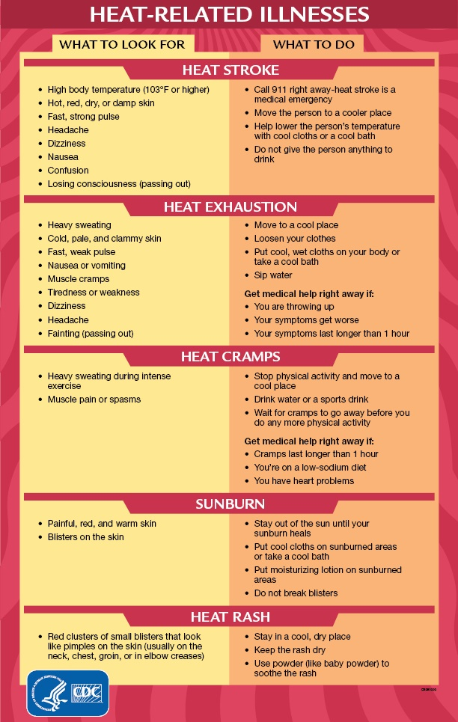
Source: Centers for Disease Control, https://www.cdc.gov/disasters/extremeheat/warning.html

Notes from heat analyses
- In the U.S., more people die from hot weather on average (131 from 1987-2016), than for any other weather-related cause (next is 84 for floods) (source: NWS, http://www.nws.noaa.gov/om/hazstats.shtml)
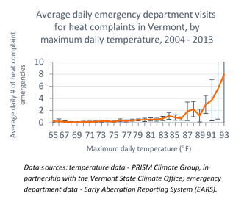
- There are about 80 emergency department visits for heat complaints in Vermont each year, but have slowly been increasing over time
- On days when the statewide average temperature reached at least 87°F:
  - heat-related emergency department visits occurred eight times more frequently (3.3 ED visits/day v. 0.4)
  - there was one additional death per day among individuals age 65 and older (11.5 deaths v. 10.6)
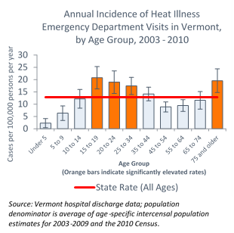
    - Over 60 percent of the excess deaths on hot days were attributed to heart conditions, stroke, and other neurologic conditions (all of which are conditions known to be exacerbated by hot weather).
- Hospital data indicate two age groups are at particularly high risk for heat illnesses in Vermont:
  - Adults age 75 and older.
  - Adolescents and young adults age 15-34.

Are Vermonters / Northerners at particularly high risk?
- People living in the Northeast generally experience heat illnesses at lower temperatures than people living in the South.
- Some of the reasons for this northern vulnerability include:
  - It is hard to acclimate to very hot weather when we experience it so infrequently
  - It can be challenging to recognize the risks and modify behaviors when we experience hot weather so infrequently
  - Many buildings in Vermont are not air conditioned, making it harder to find relief

Who is at highest risk?
- People with more exposure to hot conditions
  - Outdoor workers and hobbyists
  - Homeless persons
  - Urban residents
  - People in buildings without air conditioning
- People more sensitive to heat exposure
  - Anyone not acclimated to warmer weather
  - Older adults and young children
  - Overweight or with chronic medical conditions
  - Using recreational drugs, alcohol, or some prescription meds
    - including those that narrow your blood vessels (vasoconstrictors), regulate your blood pressure by blocking adrenaline (beta blockers), rid your body of sodium and water (diuretics), reduce psychiatric symptoms (antidepressants or antipsychotics), or stimulants for attention-deficit/hyperactivity disorder (ADHD)
- People with limited adaptation resources
  - Living alone
  - No personal transportation options
  - No air conditioning or can’t afford to run it

Why are children at greater risk?
- Kids tend to be outside and very active during the summer
- Small body size means that children’s bodies heat up faster than adults
- Kids have less sweating capacity than adults, reducing their ability to cool by evaporation
- Young children (0-4 years old) are particularly vulnerable due to their dependency on others for care

Where do hot weather emergencies take place?
- Per capita, the rate of heat-related EMS calls is 50% higher in urban areas compared to surrounding suburban areas
- Heat-related EMS calls are most often dispatched to residences. These calls disproportionately involve older adults.
- Other common locations for heat-related EMS calls include: places of recreation, outside on or next to a street, and places of business

Urban heat islands
- Per capita, the rate of heat-related EMS calls is 50% higher in urban areas compared to surrounding suburban areas
- Urban areas in Vermont have surface temperatures on average 4°F warmer than surrounding areas
- Lack of tree cover, more paved surfaces and rooftops, and higher housing density all contribute

Heat vulnerability index
- The Vermont Heat Vulnerability Index draws together 17 different measures of vulnerability in six themes: population, socioeconomic, health, environmental, climate, and heat illness.
- This is a first step to identify populations that may be more vulnerable to extreme heat, however local knowledge should always be considered when it is available.
- http://healthvermont.gov/climate/, Vermont Heat Vulnerability Index

Heat acclimatization
- Hot weather early in the year can be particularly dangerous
- It typically takes 7-14 days of activity in hot weather for a person to adapt to warmer conditions
- As the weather warms, it is important to ease in and gradually increase outdoor activity
- When hot days are infrequent, very little acclimatization will occur; acclimatization diminishes after a few weeks without hot weather exposure
- In 2016, temperatures exceeded 87°F for three days in late May, including 88°F on the day of the Vermont City Marathon (May 29). There were 19 emergency-department visits for heat complaints during the last two days.

Climate change
- As the climate warms and there are more hot days, more heat-related illnesses and deaths will occur, although some of these impacts can be avoided by taking actions to prepare and adapt.
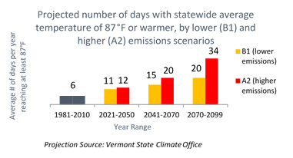
- The number of days reaching a statewide average of at least 87°F is expected to increase in the future due to climate change:
  - 6 days/year currently (1981-2010 average)
  - 15-20 by mid-century
  - 20-34 by end of century

National Weather Service policy change
- Based on a 2016 National Weather Service (NWS) policy change - starting in 2018, the NWS will issue heat advisories in the New England region (including Vermont) when the Heat Index is forecast to be 95-104°F for 2 or more consecutive hours.
  - Before 2017, advisories were issued when the Heat Index was forecast to be between 100-104°F for 2 consecutive hours; in 2017, it was changed to 95-99°F for 2 or more onsecutive days, or 100-104°F for any duration.
  - NWS announcement: http://www.nws.noaa.gov/os/notification/pns17-18heat_new_england.htm
  - This change was influenced by research from the Northeast Regional Heat Collaborative, composed of Climate & Health program staff in Maine, New Hampshire, Rhode Island, and Vermont, and researchers at Brown University.
- The NWS Experimental Enhanced Hazardous Weather Outlook (www.weather.gov/btv/ehwo) provides a 5-tiered risk rating: none (<80°F heat index), limited (80-89°F), elevated (90-94°F), significant (95-104°F), and extreme (>=105°F)
  - Historical ED visits by risk rating, based on heat index at BTV station: none (23% of ED visits), limited (41%, occurs about 42 times/year), elevated (19%, 7 times/year), significant (16%, 2-3 times/year), extreme (1%, once every 5 years)
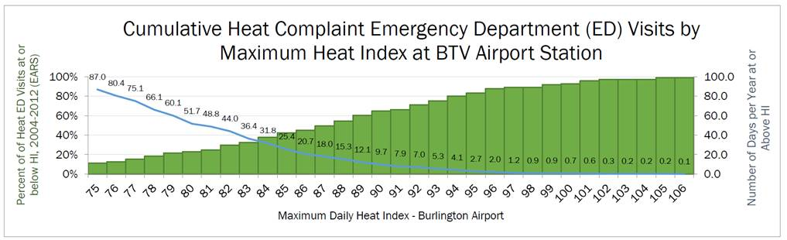

Social media posts
More hot weather social media posts & graphics:
- https://www.weather.gov/wrn/summer2018-heat-sm
- https://www.cdc.gov/disasters/extremeheat/social_media.html

Hot weather forecast
Facebook
The National Weather Service is forecasting high temperatures to be in the 90s for much of Vermont for this weekend and into next week, with the forecasted heat index exceeding 100°F on Sunday and Monday. Keep your cool in hot weather! Drink more fluids than usual, take extra breaks from strenuous activities, seek shade and cool indoor locations, and check-in on loved ones and neighbors. healthvermont.gov/climate/heat #VTHeatSafety

Twitter
Temperatures are forecast to be in the 90s this weekend and next week. Drink fluids, take breaks, seek shade and cool indoor locations, and check-in on loved ones and neighbors. healthvermont.gov/climate/heat #VTHeatSafety

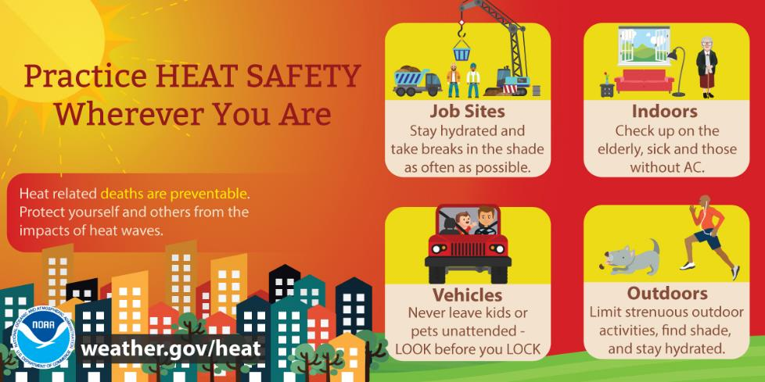

Hot weather safety
Facebook
Vermonters are at greater risk for serious heat-related illnesses, and even death, when the statewide average temperature reaches 87°F or hotter. Keep your cool in hot weather! Drink more fluids than usual, take extra breaks from strenuous activities, seek shade and cool indoor locations, and check-in on loved ones and neighbors. healthvermont.gov/climate/heat #VTHeatSafety

Heat can be dangerous. Heat can cause serious illness, even death. Stay cool, stay hydrated, and stay informed. Learn more about how to stay safe during the heat wave. www.healthvermont.gov/climate/heat #VTHeatSafety

Heat can affect anyone, but some people are more vulnerable than others. Know the signs and symptoms of heat illnesses, and get immediate medical help if you are concerned about someone’s condition. www.cdc.gov/disasters/extremeheat/warning.html #VTHeatSafety

Twitter
Keep your cool in hot weather! Drink more fluids than usual, take extra breaks from strenuous activities, seek shade and cool indoor locations, and check-in on loved ones and neighbors. healthvermont.gov/climate/heat #VTHeatSafety

Heat can be dangerous. Heat can cause serious illness, even death. Stay cool, stay hydrated, and stay informed. Learn more about how to stay safe. www.healthvermont.gov/climate/heat #VTHeatSafety

Heat can affect anyone. Know the signs and symptoms of heat illnesses, and get immediate medical help if you are concerned about someone’s condition. www.cdc.gov/disasters/extremeheat/warning.html #VTHeatSafety

Don’t be a stranger
Facebook
Older adults and people with chronic medical conditions or disabilities are generally at higher risk during hot weather, especially if they live alone or don’t have air-conditioning. Check in on your loved ones and neighbors to make sure they are drinking enough water and are staying cool. Remind them to take heat seriously! healthvermont.gov/climate/heat #VTHeatSafety

Twitter
Check in on your loved ones and neighbors to make sure they are drinking enough water and are staying cool. healthvermont.gov/climate/heat #VTHeatSafety
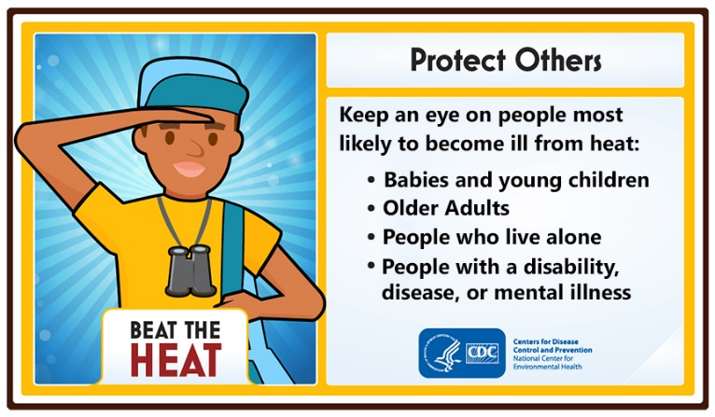

Teens & Young Adults
Facebook
Did you know that teens and young adults are more likely that the average Vermonter to go to the emergency department for a heat illness? Protect yourself from the heat while working or playing outside. Drink plenty of water, or non-alcoholic and decaffeinated fluids. Limit outdoor activities during the hottest part of the day. Wear lightweight, light-colored clothing to reflect heat and sunlight. Seek relief in air-conditioned spaces or other cool and shady places. healthvermont.gov/climate/heat #VTHeatSafety

Twitter
Protect yourself from the heat while working or playing outside. Drink more fluids than usual, take extra breaks in the shade, and wear lightweight, light-colored clothing. healthvermont.gov/climate/heat #VTHeatSafety

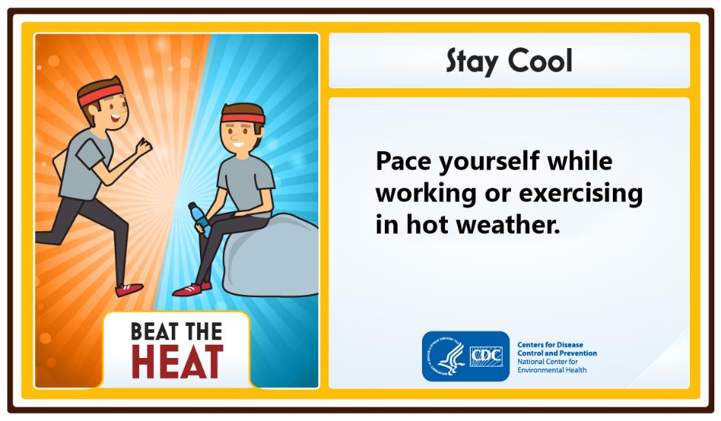

Auto Safety
Facebook
NEVER leave children, people with disabilities, older adults, or pets in parked vehicles. Temperatures inside a parked vehicle can rapidly rise to a dangerous level. Leaving windows slightly open does not significantly decrease the heating rate. Effects can be more severe on children because their bodies are not able to efficiently regulate temperature. Look Before You Lock! www.wheresbaby.org #VTHeatSafety

Twitter
NEVER leave children, people with disabilities, older adults, or pets in parked vehicles. Look Before You Lock! www.wheresbaby.org #VTHeatSafety

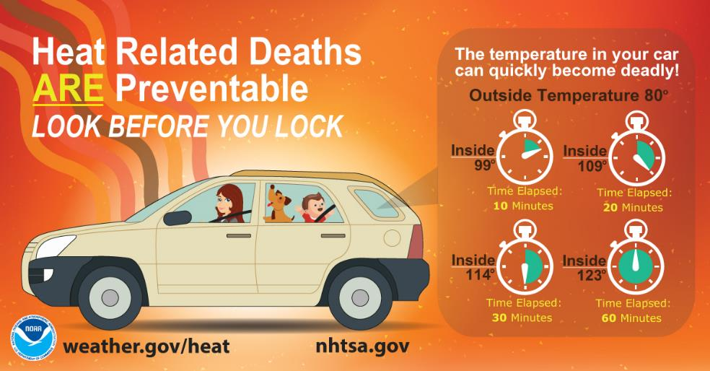

Outdoor workers
Facebook
Outdoor workers can be at higher risk for heat illnesses. During hot weather, outdoor workers need more water, rest breaks, and shade than usual. Make sure your workplace has a policy to modify or cancel activities on hot days, and a plan for providing medical attention for a heat-related illness. Learn to recognize symptoms of heat illnesses and look out for each other! www.osha.gov/heat #VTHeatSafety

It's going to be hot today! Be sure to get plenty of water, rest and shade if you're working outside. Check out these tips for outdoor workers. www.osha.gov/heat/ #VTHeatSafety

Twitter
Is your workplace prepared for hot weather? Water, rest, and shade are critical. Have a plan for reducing or canceling work on hot days, and for providing medical attention. www.osha.gov/heat/ #VTHeatSafety
It's going to be hot today! Be sure to get plenty of water, rest and shade if you're working outside. Check out these tips for outdoor workers. www.osha.gov/heat/ #VTHeatSafety

Heat Symptoms
Facebook
During hot and humid weather, your body's ability to cool itself is challenged. When your body heats too rapidly to cool itself properly, or when too much fluid or salt is lost through dehydration or sweating, you may experience a heat-related illness. Learn the symptoms of heat illnesses, what first aid actions to take, and when to seek medical attention. healthvermont.gov/climate/heat #VTHeatSafety

Twitter
Learn the symptoms of heat illnesses and what first aid actions to take.
healthvermont.gov/climate/heat #VTHeatSafety

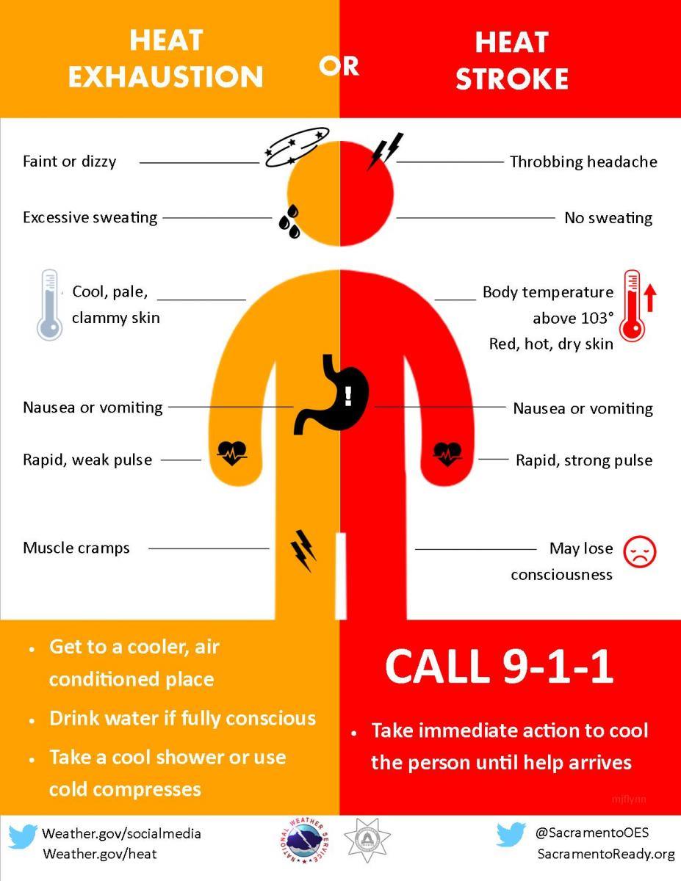

Keep Your Home Cool
Facebook
If you don’t have air conditioning, try these tips to keep your house from heating up too much: Close window shades during the day, keep windows closed when it is hotter outside than inside, and avoid using appliances and lights that generate heat, if possible. At night, open windows and use fans to blow in cooler outside air or vent out warmer inside air. healthvermont.gov/climate/heat #VTHeatSafety

Twitter
Keep your house cooler by using window shades during the day, keep windows closed when it is hotter outside than inside, and avoid using appliances and lights that generate heat, if possible. healthvermont.gov/climate/heat #VTHeatSafety

Air Quality
Facebook
Hot weather can make air quality worse, possibly causing heart and respiratory problems for some people. Older adults, children, and people with a heart condition, asthma, or other respiratory condition tend to be at higher risk when air quality is poor. Please check for air quality alerts and forecasts as they are updated by the Vermont Air Quality Division. www.airnow.gov/ #VTHeatSafety

Twitter
Hot weather can make air quality worse, possibly causing heart and respiratory problems for some people. Check air quality forecasts at www.airnow.gov/. #VTHeatSafety

Safety Tips for Communities
Facebook
Is your community ready for hot weather? Try these suggestions: Identify an air-conditioned place that people can go to find relief. Offer fun ways to stay cool, such as free or extended access to beaches and pools, host events at air-conditioned places, or provide hoses, misters or cold beverages. Offer help to family, friends, and neighbors that need extra help staying hydrated and cool. healthvermont.gov/climate/heat #VTHeatSafety

Twitter
Is your community ready for hot weather? Make sure people know where they can go to find relief, and offer help to those who need help staying hydrated and cool. healthvermont.gov/climate/heat #VTHeatSafety

