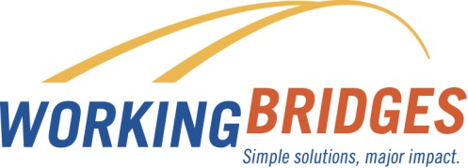**May**

**Resource of the Month**

*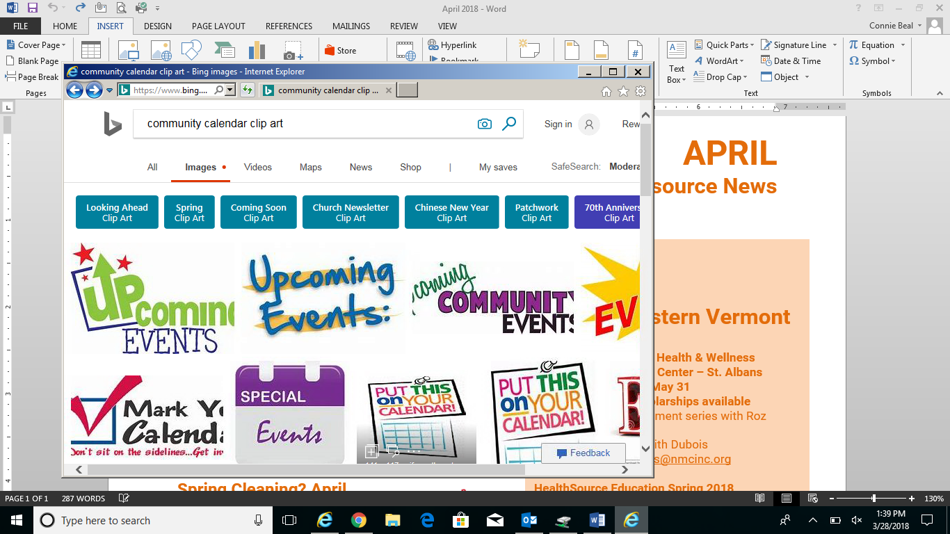***Renting in Vermont?**

**New American Safety Festival**

**Saturday, May 12th 10a-1pm**

**60 Normand Street, Winooski**

* **Car and Booster Seat Inspection and Installment**
* **Bike Helmet Fitting**
* **Sign up for FREE Swim lessons**

**Age Well Medicare Classes**

**76 Pearl Street, Essex Junction**

* **New to Medicare**

**May 15th 2-4pm**

* **Medicare Supplemental Insurance May 16th 2-4pm**
* **Understanding Prescription Drug Coverage**

**June 21st 2-4pm**

**Maintenance Monday at Old Spokes Home**

**322 North Winooski, Burlington**

* **Free help with basic maintenance to keep your bike working.**
* **Drop In**
* **Monday, May 14th 6-8pm**

Check out the ***Illustrated Guide to Vermont Renter’s Rights;*** a resource for Vermont Tenants. Ask your Resource Coordinator for a copy.

If you have questions about your tenancy call the **Vermont Tenants Hotline (800-287-7971)** and someone will talk you through your particular issues and help you understand the best options for you.

**Old Spokes Home and Community Workshop**

**Old Spokes Home** sells new bikes, used bikes, offer full service repairs, new and used parts, accessories, and more.

And, because transportation is typically a household's second greatest expense after housing, our Everybody Bikes program at our **Community Workshop** lowers barriers to bicycling by making bikes and accessories more affordable for income-eligible Vermonters.

**Age Well Helpline**

**1-800-642-5119**

Individuals, family members, and caregivers can call the Helpline for information and resources for senior housing and transportation, Medicare, caregiver support, long term care and in-home services.

Contact Lisa Jensen

Working Bridges Resource Coordinator

**802-922-6297 /** [**lisaj@unitedwaynwvt.org**](mailto:lisaj@unitedwaynwvt.org)

Lisa is onsite for the UVM Custodial Services Department on Wednesdays

FREE  CONFIDENTIAL ONSITE

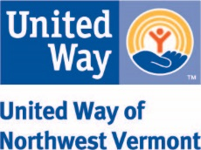

**Contact Working Bridges Resource Coordinator**

**Connie Beal 802-881-4218 connie@unitedwaynwvt.org**