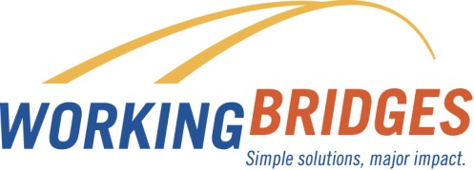**APRIL**

**Resource of the Month**

**Transportation Options**

Stop by the Resource room and learn about different ways to get to work through GoVermont, Chittenden County Bikeshare, Everybody Bikes Program, or the Green Mountain Transit system. Thinking about buying a new or used car? Know your rights before you buy! Ask Lisa about the Consumer Assistance Program.

**Home Owner University**

**This one-day university offers 12 workshops that will help you maintain your home, invest for the future, and plan for improvements you may want to make to your home.**

* ***$25 per household***
* ***Includes lunch***
* ***April 28th***

**Are you renting in Vermont?**

* ***Free tenant skills class –*** 
  + ***April 9 and April 18***
* ***Free handbook***
* ***Free tenant counseling***

**Health Source Education Spring 2018**

**UVM Medical Center - Burlington**

* ***Spring Into Summer: Skin Care Tips for Health Aging – April 23 6pm-7pm***
* ***Older Adult Housing Options: It’s Not One Size Fits All – April 30 6pm-7:30pm***

**Spring Cleaning? April 28th is Prescription Drug Take Back Day 10am – 2pm**

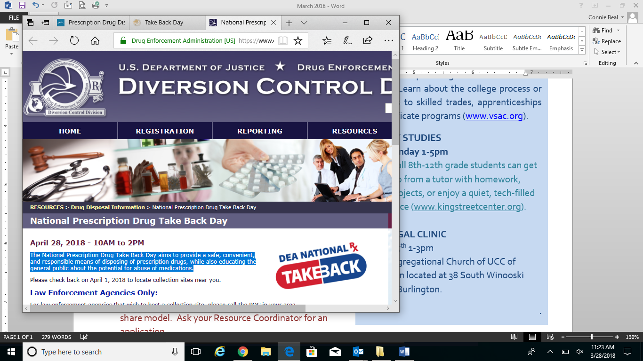The National Prescription Drug Take Back Day aims to provide a safe, convenient, and responsible means of disposing of prescription drugs, while also educating the general public about the potential for abuse of medications. Contact your Resource Coordinator to find a drop off site located near you.

**Flynn Ticket Vouchers still available!**

*Jessica Lang Dance on Saturday, April 21 at 8:00 PM*

*VSO Masterworks on Saturday, May 5 at 7:30pm*

*VYO Spring Concert on Sunday, May 6 at 3pm*

*Othello on Monday, May 7 at 9:30 AM*

*Shh…We Have a Plan on Wednesday, May 9 at 6:00 PM*

Contact Lisa Jensen

Working Bridges Resource Coordinator

**802-922-6297 / lisaj@unitedwaynwvt.org**

Lisa is at UVM on Wednesdays for the Custodial Services Department

FREE  CONFIDENTIAL ONSITE

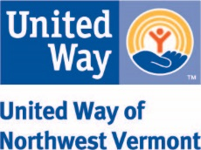

**Contact Working Bridges Resource Coordinator**

**Connie Beal 802-881-4218 connie@unitedwaynwvt.org**