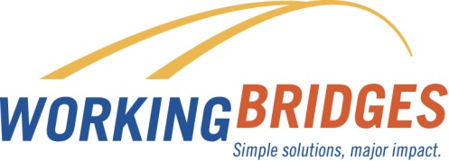**March**

**Resource News**

**240,000 Vermonters - 30 Minutes**

**Upcoming Community**

**Events**

**COLLEGE AND CAREER DAY**

**March 17th 9am-1:30pm**

Free workshops for high school students and parents. Learn about the college process or pathways to skilled trades, apprenticeships and certificate programs ([www.vsac.org](http://www.vsac.org)).

**SUNDAY STUDIES**

**Every Sunday 1-5pm**

Any and all 8th-12th grade students can get extra help from a tutor with homework, school projects, or enjoy a quiet, tech-filled study space ([www.kingstreetcenter.org](http://www.kingstreetcenter.org)).

**FREE LEGAL CLINIC**

March 25th 1-3pm

First Congregational Church of UCC of Burlington located at 38 South Winooski Avenue, Burlington.

.

.

Sign up to meet with your Resource Coordinator to get your free credit report in less than 30 minutes. Make sure you are not a Vermonter affected by the Equifax breach.

**Tax Refund or No Tax Refund**

Talk with your Resource Coordinator about the different ways to save money using your refund or to plan ahead for the 2018 tax preparation year. Learn about the 30-40-30 plan!

**Farm Fresh Food! Apply Now!**

The Farm Share Program provides limited-income Vermonters with the opportunity to support their local CSA farmer and receive reliable access to high-quality produce on weekly basis through an innovative cost-share model. Ask your Resource Coordinator for an application.

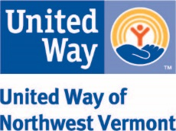

Contact Lisa Jensen

Working Bridges Resource Coordinator

**802-922-6297 /** [**lisaj@unitedwaynwvt.org**](mailto:lisaj@unitedwaynwvt.org)

Lisa is onsite for the UVM Custodial Service Department on Wednesdays

FREE  CONFIDENTIAL ONSITE

**Contact Working Bridges Resource Coordinator**

**Connie Beal 802-881-4218 connie@unitedwaynwvt.org**