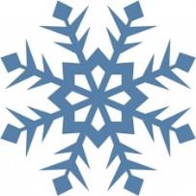
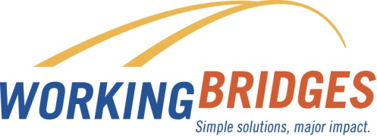
January
Resource News

Energy and heating costs can be expensive this time of year. Meet with your Working Bridges Resource Coordinator to learn about programs that may help with heating bills, energy efficiency programs and weatherization. Whether you rent or own a home, find out if community resources can help you manage the costs of winter.
Upcoming
Community
Events

FREE LEGAL CLINIC at the First Congregational Church of UCC of Burlington located at 38 South Winooski Avenue, Burlington. Next clinic is January 21st from 1pm to 3pm. Volunteer Vermont attorneys will offer pro-bono FREE legal counsel to anyone in the community. All Legal concerns and Family Law Specialist. All are welcome to access this service with any legal questions. Confidentiality is guaranteed.

HOME BUYER WORKSHOP in St. Albans – two part workshop scheduled for January 13th and January 20th from 9:30a-1pm. Call Champlain Housing Trust at 802-527-2361 or go to www.getahome.org/programs.
.
If you own a home, read about Efficiency Vermont’s energy justice efforts through Efficiency Vermont’s Community Energy Partnership Program at www.efficiencyvermont.com/news or call
1-888-921-5990.

Help Stop Scams!
More than 2,500 fraud complaints were filed from Vermonters in 2016. You can sign up to receive alerts by email, text or recorded telephone messages when a new scam is making the rounds. To sign up for VT Scam Alert, go to uvm.edu/consumer or call the Vermont Attorney General’s Consumer Protection office at 800-649-2424.

FAFSA Fridays at VSAC
VSAC helpline & walk-in assistance
January 5, 12, 19 and 26.
10:00am - 3:00pm VSAC Resource Center in Winooski
Will you be filing a FAFSA? The Free Application for Federal Student Aid is your pathway to funding for the education and career training after high school. Every student should file!
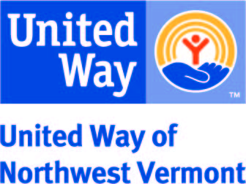
Want more information about community resources? Contact Lisa Jensen,
Working Bridges Resource Coordinator
802-922-6297 / lisaj@unitedwaynwvt.org

Available to UVM Custodial Services employees
FREE CONFIDENTIAL
Contact Working Bridges Resource Coordinator
Connie Beal 802-881-4218 connie@unitedwaynwvt.org

