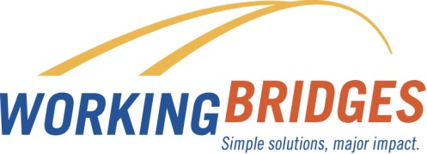
DECEMBER
Resource News
Upcoming Community Events
OId Spokes Home in Burlington
FREE Kids Bike Giveaway (ages 3 – 8) December 14th, 2017
Sustainability Academy - 123 North Street, Burlington 5:30pm – 8 pm

Mercy Connections American Citizenship Preparation Class
Beginning Tuesdays in January
Register: 802-846-7162
This class prepares students for the U.S. Citizenship Test by increasing your English language skills while you study United States history, government, and geography. In each class, we will also practice questions and answers from the U.S. Citizenship Test.
- Free, online resources are available to help prepare for the Citizenship exam https://my.uscis.gov/prep/test/civics
- Download the USCIS Civics Test Study Tool app to practice test questions (available through the App Store or Google Play)

The winter season brings joy for many, but can also be stressful. Caregivers who provide support to a loved one may feel added pressures during this time. Here are some key community resources that may be helpful to caregivers. Contact your Resource Coordinator for more details.

Queen City Memory Café
A monthly gathering in Burlington, Vermont for people living with dementia and other forms of memory loss and their care partners. The free café offers entertainment, socializing and refreshments. Learn more at https://www.queencitymemorycafe.com/
Meets the 3rd Saturday of the month 10:00am – 11:30am
802-656-4220 jnunziat@uvm.edu

Vermont Alzheimer’s Association
Caregiver Resource Center
https://www.alz.org/care/
If you take care of a loved one with dementia or Alzheimer’s, learn about online support groups via AlzConnected https://www.alzconnected.org/discussion.aspx

AgeWell Vermont (Formerly Champlain Valley Agency on Aging, CVAA) provides programs and services for people 60 and over as well as their care partners. Visit www.agewellvt.org or call 1-800-642-5119
Want more information about community resources? Contact Lisa Jensen,
Working Bridges Resource Coordinator
802-922-6297 / lisaj@unitedwaynwvt.org
Lisa is onsite for the Custodial Services Department at UVM on Wednesdays

FREE CONFIDENTIAL
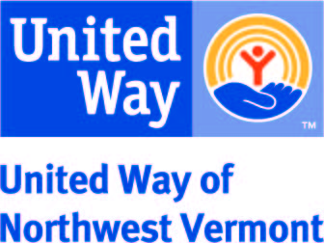
Contact Working Bridges Resource Coordinator
Connie Beal 802-881-4218 connie@unitedwaynwvt.org

