

2018 Performance Season

Flynn Theater $2 Ticket Vouchers

Available to employees of the Custodial Service Department at UVM

First-come, first-served\*

The PACT Program (Providing Accessible Community Tickets) partners with more than 50 agencies to make performances accessible and affordable to every member of the community. Each season more than 3500 vouchers are distributed allowing over 1500 people to experience live performance at the Flynn. Exposure to the performing arts allows all audience members, regardless of economic status or physical or emotional ability, to explore who we are and what we can be, as individuals and as members of society.

\*Quantities limited to 2 per employee. Contact your Working Bridges Resource Coordinator for more information about reserving vouchers for the following shows:

• DBR & Marc Bamuthi Joseph on Friday, January 19 at 8:00 PM

• Jabber on Thursday, February 15 at 9:30 AM

• Manual Cinema on Wednesday, February 21 at 7:30 PM

• Bedlam Theater: Hamlet on Wednesday, February 28 at 7:30 PM

• Urban Bush Women on Friday, March 9 at 10:00 AM

• Urban Bush Women on Friday, March 9 at 8:00 PM

• Carnival Caravan on Friday, March 16 at 9:30 AM

• VYO & VSO Link Up: The Orchestra Moves on Thursday,

March 22 at 10:00 AM

• Jessica Lang Dance on Saturday, April 21 at 8:00 PM

• Othello on Monday, May 7 at 9:30 AM

• Shh…We Have a Plan on Wednesday, May 9 at 6:00 PM

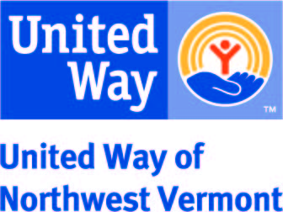

Contact Lisa Jensen, Working Bridges Resource Coordinator at 802-922-6297 or email [lisaj@unitedwaynwvt.org](mailto:lisaj@unitedwaynwvt.org)