Backyard Chicken Sampling Information
Etter Lab Research Study 2022
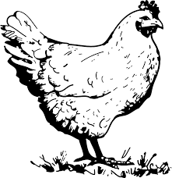
Owner Name (First Last)
Date sample taken:
Location of farm (nearest town)
Rural/urban/semi-rural
Number of chickens in flock:
Age(s) of chickens (e.g., adult, pullet, chick)
Chicken housing type (indoor only; indoor w/ penned run; free range, or other housing type)
Breeds of chickens:

